MINI PROJECT

(SESSION-2020-2021)

EXPENSE MANAGER WEBSITE

Report



**Institute of Engineering & Technology**

**Team Members**

**NAMAN MAHESHWARI**

**(181500411)**

**NIKHIL BAGHEL**

**(181500424)**

## Supervised By

**MR. ANAND GUPTA**

**TECHNICAL TRAINER**

**Department of Computer Engineering &Technology**

**Department of Computer Engineering and Applications**

**GLA University, Mathura**

**17 km. Stone NH#2, Mathura-Delhi Road, P.O. – Chaumuha,**

**Mathura – 281406**



**Declaration**

I hereby declare that the work which is being presented in the Mini Project **“Expense Manager Website”,** in partial fulfillment of the requirements for Mini project Lab is an authentic record of my own work carried under the supervision of **Mr. Anand Gupta, Technical Trainer.**

**Naman Maheshwari**

**Nikhil Baghel**

**Department of Computer Engineering and Applications**

**GLA University, Mathura**

**17 km. Stone NH#2, Mathura-Delhi Road, P.O. – Chaumuha,**

**Mathura – 281406**



**Certificate**

This is to certify that the project entitled “Expense Manager Website” carried out in Mini Project lab – I . The work done by Naman Maheshwari (181500411), Nikhil Baghel (181500424) and is submitted in partial fulfillment of the requirements for the award of the degree Bachelor of Technology (Computer Science & Engineering).

**Signature of Supervisor:**

**Name of Supervisor: Mr. Anand Gupta**

**Date:19/11/2020**

**Acknowledgement**

It gives us a great sense of pleasure to present the report of the B. Tech Mini Project undertaken during B. Tech. Third Year. This project in itself is an acknowledgement to the inspiration, drive and technical assistance contributed to it by many individuals. This project would never have seen the light of the day without the help and guidance that we have received.

Our heartiest thanks to Dr. (Prof). Anand Singh Jalal, Head of Dept., Department of CEA for providing us with an encouraging platform to develop this project, which thus helped us in shaping our abilities towards a constructive goal.

We owe special debt of gratitude to Mr. Anand Gupta, Technical Trainer, for his constant support and guidance throughout the course of our work. His sincerity, thoroughness and perseverance have been a constant source of inspiration for us. He has showered us with all his extensively experienced ideas and insightful comments at virtually all stages of the project & has also taught us about the latest industry-oriented technologies.

We also do not like to miss the opportunity to acknowledge the contribution of all faculty members of the department for their kind guidance and cooperation during the development of our project. Last but not the least, we acknowledge our friends for their contribution in the completion of the project.

**NAMAN MAHESHWARI**

**NIKHIL BAGHEL**

**Abstract**

As we know, the present world is using advanced 4G and 5G technology, so it is easy to manage our budget and expenses on an Online Application rather than on a diary. Moreover, it is difficult to have a pen and diary with us all the time because Some time, we are in office, restaurant or at important place.

In this project, we build a simple expense manager website that can be used by all for tracking their expenses accordingly. The website can be used to plan out the expenses for a group of people. Further, the user can also add bills under the given budget and track her expenses accordingly. This website would be built using HTML, CSS, Bootstrap, JavaScript MySQL and PHP. As we know, HTML is used to structure a website, CSS (cascading style sheets) are used to styling a webpage.

**Table of Contents**

**Certificate 2**

**Acknowledgement 3**

**Abstract 4**

**Introduction 7**

**Definitions 8**

**Tool Used 11**

**Requirements 19**

**Software Design 20**

**Testing 27**

**Implementation 53**

**Database 58**

**References 60**

**Introduction**

In this project, we build a simple expense manager website, that manage your daily expenses, manage them between you and your friends. The basic idea behind this project is to ease the process of managing account. As we see, the technology increase day by day, so it is better to manage things online rather than note down with a pen in a diary. The user can add the initial budget for the expenses and give it a title accordingly. Further user can add bills under the budget and track her expenses accordingly.

The technology used in this project are HTML (Hypertext Markup Language), CSS(cascading style sheets), JavaScript, Bootstrap ,SQL(Structured Query Language) and PHP(Hypertext Pre-processor).

The website will contain the following pages:

1. Index Page

2. Sign up Page

3. Login Page

4. About Us Page

5. Home Page

6. Add New Plan Page

7. View Plan Page

8. Expense Distribution Page

9. Add New Expense Page

10. Change Password Page

**Objective**

The objective is to build a simple expense manager web application that can be used by all for tracking their expenses accordingly. The user can add the initial budget for the expenses and give it a title accordingly. Further user can add bills under the given budget and track his/her expenses accordingly

**Definitions**

**ADMIN**

The **Administrator** application, also known as the Back-end, **Admin Panel** or Control **Panel**, is the interface where administrators and other site officials with appropriate privileges can manipulate the look of a Joomla! powered web site. In our website we have the admin pannel where admin can add the category attributes which specifies the features and speciality of the particular artist.

**VISUAL STUDIO**

Microsoft Visual Studio is an integrated development environment (IDE) from Microsoft. It is used to develop computer programs, as well as websites, web apps, web services and mobile apps. Visual Studio uses Microsoft software development platforms such as Windows API, Windows Forms, Windows Presentation Foundation, Windows Store and Microsoft Silverlight. It can produce both native code and managed code.

Visual Studio includes a code editor supporting IntelliSense (the code completion component) as well as code refactoring. The integrated debugger works both as a source-level debugger and a machine-level debugger. Other built-in tools include a code profiler, forms designer for building GUI applications, web designer, class designer, and database schema designer. It accepts plug-ins that enhance the functionality at almost every level—including adding support for source control systems (like Subversion and Git) and adding new toolsets like editors and visual designers for domain-specific languages or toolsets for other aspects of the software development lifecycle (like the Team Foundation Server client: Team Explorer).

Visual Studio supports 36 different programming languages and allows the code editor and debugger to support (to varying degrees) nearly any programming language, provided a language-specific service exists. Built-in languages include C, C++, C++/CLI, Visual Basic .NET, C#, F#, JavaScript, TypeScript, XML, XSLT, HTML, and CSS. Support for other languages such as Python, Ruby, Node.js, and M among others is available via plug-ins. Java (and J#) were supported in the past.

Microsoft Visual Studio is an [integrated development environment](https://en.wikipedia.org/wiki/Integrated_development_environment) (IDE) from [Microsoft](https://en.wikipedia.org/wiki/Microsoft). It is used to develop [computer programs](https://en.wikipedia.org/wiki/Computer_program), as well as [websites](https://en.wikipedia.org/wiki/Web_site), [web apps](https://en.wikipedia.org/wiki/Web_app), [web services](https://en.wikipedia.org/wiki/Web_service) and [mobile apps](https://en.wikipedia.org/wiki/Mobile_app). Visual Studio uses Microsoft software development platforms such as [Windows API](https://en.wikipedia.org/wiki/Windows_API), [Windows Forms](https://en.wikipedia.org/wiki/Windows_Forms), [Windows Presentation Foundation](https://en.wikipedia.org/wiki/Windows_Presentation_Foundation), [Windows Store](https://en.wikipedia.org/wiki/Windows_Store) and [Microsoft Silverlight](https://en.wikipedia.org/wiki/Microsoft_Silverlight). It can produce both [native code](https://en.wikipedia.org/wiki/Machine_code) and [managed code](https://en.wikipedia.org/wiki/Managed_code).

Visual Studio includes a [code editor](https://en.wikipedia.org/wiki/Code_editor) supporting [IntelliSense](https://en.wikipedia.org/wiki/IntelliSense) (the [code completion](https://en.wikipedia.org/wiki/Code_completion) component) as well as [code refactoring](https://en.wikipedia.org/wiki/Code_refactoring). [The integrated debugger](https://en.wikipedia.org/wiki/Microsoft_Visual_Studio_Debugger) works both as a source-level debugger and a machine-level debugger. Other built-in tools include a [code profiler](https://en.wikipedia.org/wiki/Profiling_(computer_programming)), forms designer for building [GUI](https://en.wikipedia.org/wiki/GUI) applications, [web designer](https://en.wikipedia.org/wiki/Web_designer), [class](https://en.wikipedia.org/wiki/Class_(computing)) designer, and [database schema](https://en.wikipedia.org/wiki/Database_schema) designer. It accepts plug-ins that enhance the functionality at almost every level—including adding support for [source control](https://en.wikipedia.org/wiki/Source_control) systems (like [Subversion](https://en.wikipedia.org/wiki/Subversion_(software)) and [Git](https://en.wikipedia.org/wiki/Git)) and adding new toolsets like editors and visual designers for [domain-specific languages](https://en.wikipedia.org/wiki/Domain-specific_language) or toolsets for other aspects of the [software development lifecycle](https://en.wikipedia.org/wiki/Software_development_lifecycle) (like the [Team Foundation Server](https://en.wikipedia.org/wiki/Team_Foundation_Server) client: Team Explorer).

Visual Studio supports 36 different [programming languages](https://en.wikipedia.org/wiki/Programming_language) and allows the code editor and debugger to support (to varying degrees) nearly any programming language, provided a language-specific service exists. Built-in languages include [C](https://en.wikipedia.org/wiki/C_(programming_language)),[C++](https://en.wikipedia.org/wiki/C++), [C++/CLI](https://en.wikipedia.org/wiki/C++/CLI), [Visual Basic .NET](https://en.wikipedia.org/wiki/Visual_Basic_.NET), [C#](https://en.wikipedia.org/wiki/C_Sharp_(programming_language)), [F#](https://en.wikipedia.org/wiki/F_Sharp_(programming_language)),[[7]](https://en.wikipedia.org/wiki/Microsoft_Visual_Studio#cite_note-7) [JavaScript](https://en.wikipedia.org/wiki/JavaScript), [TypeScript](https://en.wikipedia.org/wiki/TypeScript), [XML](https://en.wikipedia.org/wiki/XML), [XSLT](https://en.wikipedia.org/wiki/XSLT), [HTML](https://en.wikipedia.org/wiki/HTML), and [CSS](https://en.wikipedia.org/wiki/Cascading_Style_Sheets). Support for other languages such as [Python](https://en.wikipedia.org/wiki/Python_(programming_language)),[[8]](https://en.wikipedia.org/wiki/Microsoft_Visual_Studio#cite_note-8) [Ruby](https://en.wikipedia.org/wiki/Ruby_(programming_language)), [Node.js](https://en.wikipedia.org/wiki/Node.js), and [M](https://en.wikipedia.org/wiki/MUMPS) among others is available via [plug-ins](https://en.wikipedia.org/wiki/Plug-in_(computing)). [Java](https://en.wikipedia.org/wiki/Java_(programming_language)) (and [J#](https://en.wikipedia.org/wiki/J_Sharp)) were supported in the past.

The most basic edition of Visual Studio, the Community edition, is available free of charge.

The currently supported Visual Studio version is 2019.

**WEB BROWSER**

A **web browser** (commonly referred to as a **browser**) is a [software application](https://en.wikipedia.org/wiki/Software_application) for accessing information on the [World Wide Web](https://en.wikipedia.org/wiki/World_Wide_Web). Each individual [web page](https://en.wikipedia.org/wiki/Web_page), image, and video is identified by a distinct [Uniform Resource Locator](https://en.wikipedia.org/wiki/URL) (URL), enabling browsers to retrieve these resources from a [web server](https://en.wikipedia.org/wiki/Web_server) and display them on the [user](https://en.wikipedia.org/wiki/User_(computing))'s device.

A web browser is not the same thing as a [search engine](https://en.wikipedia.org/wiki/Web_search_engine), though the two are often confused.[[1]](https://en.wikipedia.org/wiki/Web_browser#cite_note-1)[[2]](https://en.wikipedia.org/wiki/Web_browser#cite_note-2) For a user, a search engine is just a [website](https://en.wikipedia.org/wiki/Website), such as [google.com](https://en.wikipedia.org/wiki/Google_Search), that stores searchable data about other websites. But to connect to a website's server and display its web pages, a user needs to have a web browser installed on their device.[[3]](https://en.wikipedia.org/wiki/Web_browser#cite_note-3)

The most popular browsers are [Chrome](https://en.wikipedia.org/wiki/Google_Chrome), [Firefox](https://en.wikipedia.org/wiki/Firefox), [Safari](https://en.wikipedia.org/wiki/Safari_(web_browser)), [Internet Explorer](https://en.wikipedia.org/wiki/Internet_Explorer), and [Edge](https://en.wikipedia.org/wiki/Microsoft_Edge)

**BOOTSTRAP**

Bootstrap is a free and open-source front-end web framework. It contains HTML and CSS-based design templates for typography, forms, buttons, navigation and other interface components, as well as optional JavaScript extensions. Unlike many earlier web frameworks, it concerns itself with front-end development only.

Bootstrap is the third-most-starred project on GitHub, with more than 131,000 stars, behind only free CodeCamp (almost 300,000 stars) and marginally behind Vue.js framework. According to Alexa Rank, Bootstrap getbootstrap.com is in the top-2000 in US while vuejs.org is in top-7000 in US.

**MYSQL**

MySQL is an open source relational database management system (RDBMS). Its name is a combination of "My", the name of co-founder Michael Widenius's daughter, and "SQL", the abbreviation for Structured Query Language.

MySQL is free and open-source software under the terms of the GNU General Public License, and is also available under a variety of proprietary licenses. MySQL was owned and sponsored by the Swedish company MySQL AB, which was bought by Sun Microsystems (now Oracle Corporation).In 2010, when Oracle acquired Sun, Widenius forked the open-source MySQL project to create MariaDB.

MySQL is a component of the LAMP web application software stack (and others), which is an acronym for Linux, Apache, MySQL, Perl/PHP/Python. MySQL is used by many database-driven web applications, including Drupal, Joomla, phpBB, and WordPress. MySQL is also used by many popular websites, including Google (though not for searches), Facebook, Twitter, Flickr, and YouTube.

MySQL is written in C and C++. Its SQL parser is written in yacc, but it uses a home-brewed lexical analyzer.MySQL works on many system platforms, including AIX, BSDi, FreeBSD, HP-UX, eComStation, i5/OS, IRIX, Linux, macOS, Microsoft Windows, NetBSD, Novell NetWare, OpenBSD, OpenSolaris, OS/2 Warp, QNX, Oracle Solaris, Symbian, SunOS, SCO OpenServer, SCO UnixWare, Sanos and Tru64. A port of MySQL to OpenVMS also exists.

The MySQL server software itself and the client libraries use dual-licensing distribution. They are offered under GPL version 2, or a proprietary license.

Support can be obtained from the official manual. Free support additionally is available in different IRC channels and forums. Oracle offers paid support via its MySQL Enterprise products. They differ in the scope of services and in price. Additionally, a number of third party organisations exist to provide support and services, including MariaDB and Percona.

MySQL has received positive reviews, and reviewers noticed it "performs extremely well in the average case" and that the "developer interfaces are there, and the documentation (not to mention feedback in the real world via Web sites and the like) is very, very good". It has also been tested to be a "fast, stable and true multi-user, multi-threaded sql database server".

**Tools used**

**HTML**

**Hypertext Markup Language** (**HTML**) is the standard markup language for creating web pages and web application. With Cascading Style Sheets (CSS) and JavaScript, it forms a triad of cornerstone technologies for the World Wide Web.

Web Browser receive HTML documents from a web server or from local storage and render the documents into multimedia web pages. HTML describes the structure of a web page semantically and originally included cues for the appearance of the document.

HTML Elements are the building blocks of HTML pages. With HTML constructs, images and other objects such as interactive forms may be embedded into the rendered page. HTML provides a means to create structured documents by denoting structural semantics for text such as headings, paragraphs, lists, links, quotes and other items. HTML elements are delineated by *tags*, written using angle brackets. Tags such as <img/> and <input/>directly introduce content into the page. Other tags such as <p> surround and provide information about document text and may include other tags as sub-elements. Browsers do not display the HTML tags, but use them to interpret the content of the page.

HTML can embed programs written in a [scripting language](https://en.wikipedia.org/wiki/Scripting_language) such as [JavaScript](https://en.wikipedia.org/wiki/JavaScript), which affects the behavior and content of web pages. Inclusion of CSS defines the look and layout of content. The [World Wide Web Consortium](https://en.wikipedia.org/wiki/World_Wide_Web_Consortium) (W3C), maintainer of both the HTML and the CSS standards, has encouraged the use of CSS over explicit presentational HTML since 1997.

HTML code ensures the proper formatting of text and images so that your [Internet browser](https://www.computerhope.com/jargon/b/browser.htm)may display them as they are intended to look. Without HTML, a browser would not know how to display text as [elements](https://www.computerhope.com/jargon/h/html-element.htm) or load images or other elements. HTML also provides a basic structure of the page, upon which [Cascading Style Sheets](https://www.computerhope.com/jargon/c/css.htm) are overlaid to change its appearance. One could think of HTML as the bones (structure) of a web page, and CSS as its skin (appearance).

**CSS (Cascading Style Sheets)**

**C**ascading **S**tyle **S**heets, fondly referred to as CSS, is a simple design language intended to simplify the process of making web pages presentable.

CSS handles the look and feel part of a web page. Using CSS, you can control the color of the text, the style of fonts, the spacing between paragraphs, how columns are sized and laid out, what background images or colors are used, layout designs, variations in display for different devices and screen sizes as well as a variety of other effects.

CSS is easy to learn and understand but it provides powerful control over the presentation of an HTML document. Most commonly, CSS is combined with the markup languages HTML or XHTML.

**Advantage Of CSS**

**CSS saves time** − You can write CSS once and then reuse same sheet in multiple HTML pages. You can define a style for each HTML element and apply it to as many Web pages as you want.

**Pages load faster** − If you are using CSS, you do not need to write HTML tag attributes every time. Just write one CSS rule of a tag and apply it to all the occurrences of that tag. So less code means faster download times.

**Easy maintenance** − To make a global change, simply change the style, and all elements in all the web pages will be updated automatically.

**Superior styles to HTML** − CSS has a much wider array of attributes than HTML, so you can give a far better look to your HTML page in comparison to HTML attributes.

**Multiple Device Compatibility** − Style sheets allow content to be optimized for more than one type of device. By using the same HTML document, different versions of a website can be presented for handheld devices such as PDAs and cell phones or for printing.

**Global web standards** − Now HTML attributes are being deprecated and it is being recommended to use CSS. So its a good idea to start using CSS in all the HTML pages to make them compatible to future browsers.

**BOOTSTRAP**

Bootstrap is a free and open front-end framework for designing websites and web applications. It contains HTML - and CSS -based design templates for typography, forms, buttons, navigation and other interface components, as well as optional JavaScript extensions. Unlike many earlier web frameworks, it concerns itself with front end development only.

Bootstrap is the second most-starred project on GitHub, with more than 129,000 stars. Bootstrap comes with several JavaScript components in the form of jQuery plugins. They provide additional user interface elements such as dialog boxes, tooltips, and carousels. They also extend the functionality of some existing interface elements, including for example an auto-complete function for input fields. In version 1.3, the following JavaScript plugins are supported: Modal, Dropdown, Scrollspy, Tab, Tooltip, Popover, Alert, Button, Collapse, Carousel and Typeahead.

## Getting Started with Bootstrap Basics

Bootstrap is available in two forms; as a precompiled version, and as a source code version. The source code version uses the [Less](http://lesscss.org/) CSS preprocessor, but if you are more into Sass, there is an [official Sass port of Bootstrap](https://github.com/twbs/bootstrap-sass) also available.

The source code version comes styles source code written in Less (or Sass), all the JavaScript, and accompanying documentation. This allows more ambitious designers and developers to change and customize, at their will, all the provided styles, and to build their own version of Bootstrap. But if you are not familiar with Less (or Sass), or you are just not interested in changing the source code, don’t worry. You can just use the precompiled vanilla CSS. All the styles can be overridden later by using custom styles.

## JAVA SCRIPT (JS)

**JavaScript** often abbreviated as **JS**, is a [high-level](https://en.wikipedia.org/wiki/High-level_programming_language), [interpreted](https://en.wikipedia.org/wiki/Interpreted_language) [programming language](https://en.wikipedia.org/wiki/Programming_language) that conforms to the [ECMAScript](https://en.wikipedia.org/wiki/ECMAScript) specification. It is a programming language that is characterized as [dynamic](https://en.wikipedia.org/wiki/Dynamic_programming_language), [weakly typed](https://en.wikipedia.org/wiki/Weak_typing), [prototype-based](https://en.wikipedia.org/wiki/Prototype-based_programming) and [multi-paradigm](https://en.wikipedia.org/wiki/Multi-paradigm_programming_language).

Alongside [HTML](https://en.wikipedia.org/wiki/HTML) and [CSS](https://en.wikipedia.org/wiki/CSS), JavaScript is one of the core technologies of the [World Wide Web](https://en.wikipedia.org/wiki/World_Wide_Web). JavaScript enables interactive [web pages](https://en.wikipedia.org/wiki/Web_page) and is an essential part of [web applications](https://en.wikipedia.org/wiki/Web_application). The vast majority of [websites](https://en.wikipedia.org/wiki/Website) use it, and major [web browsers](https://en.wikipedia.org/wiki/Web_browser) have a dedicated [JavaScript engine](https://en.wikipedia.org/wiki/JavaScript_engine) to execute it.

As a multi-paradigm language, JavaScript supports [event-driven](https://en.wikipedia.org/wiki/Event-driven_programming), [functional](https://en.wikipedia.org/wiki/Functional_programming), and [imperative](https://en.wikipedia.org/wiki/Imperative_programming) (including [object-oriented](https://en.wikipedia.org/wiki/Object-oriented_programming) and [prototype-based](https://en.wikipedia.org/wiki/Prototype-based_programming)) [programming styles](https://en.wikipedia.org/wiki/Programming_paradigm). It has [APIs](https://en.wikipedia.org/wiki/Application_programming_interface) for working with text, [arrays](https://en.wikipedia.org/wiki/Array_data_type), dates, [regular expressions](https://en.wikipedia.org/wiki/Regular_expression), and the [DOM](https://en.wikipedia.org/wiki/Document_Object_Model), but the language itself does not include any [I/O](https://en.wikipedia.org/wiki/Input/output), such as [networking](https://en.wikipedia.org/wiki/Computer_network), [storage](https://en.wikipedia.org/wiki/Data_storage), or [graphics](https://en.wikipedia.org/wiki/Computer_graphics) facilities. It relies upon the host environment in which it is embedded to provide these features.

Initially only implemented [client-side](https://en.wikipedia.org/wiki/Client-side) in web browsers, JavaScript engines are now embedded in many other types of host software, including [server-side](https://en.wikipedia.org/wiki/Server-side) in web servers and databases, and in non-web programs such as word processors and [PDF](https://en.wikipedia.org/wiki/Portable_Document_Format) software, and in runtime environments that make JavaScript available for writing mobile and desktop applications, including desktop widgets.

The terms *Vanilla JavaScript* and *Vanilla JS* refer to JavaScript not extended by any frameworks or additional libraries. Scripts written in Vanilla JS are plain JavaScript code.

Although there are similarities between JavaScript and [Java](https://en.wikipedia.org/wiki/Java_(programming_language)), including language name, [syntax](https://en.wikipedia.org/wiki/Syntax_(programming_languages)), and respective [standard libraries](https://en.wikipedia.org/wiki/Standard_library), the two languages are distinct and differ greatly in design. JavaScript was influenced by programming languages such as [Self](https://en.wikipedia.org/wiki/Self_(programming_language)) and [Scheme](https://en.wikipedia.org/wiki/Scheme_(programming_language)).

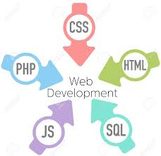

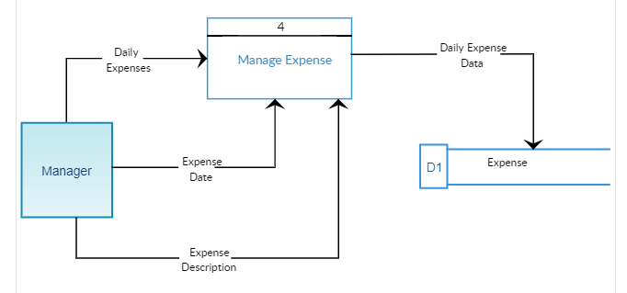

**DATA FLOW DIAGRAM**

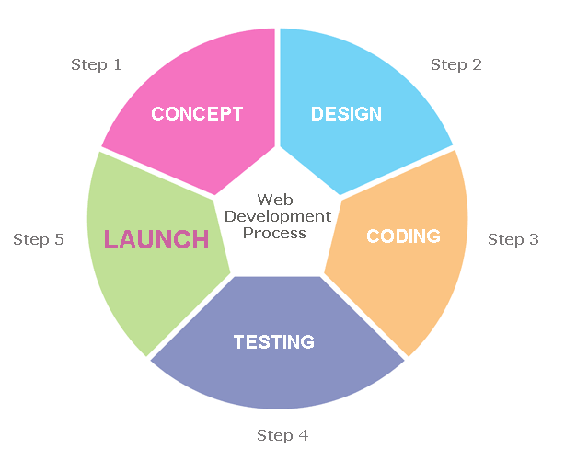

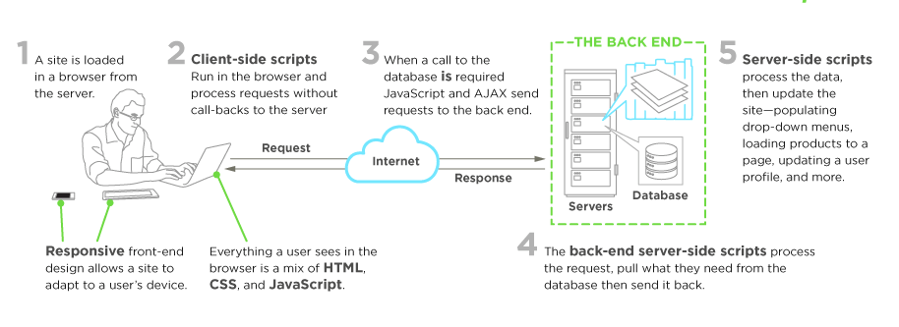

**FONT AWESOME**

Font Awesome is a [font](https://en.wikipedia.org/wiki/Font) and [icon](https://en.wikipedia.org/wiki/Icon_(computing)) toolkit based on [CSS](https://en.wikipedia.org/wiki/CSS) and [LESS](https://en.wikipedia.org/wiki/Less_(stylesheet_language)). It was made by Dave Gandy for use with [Twitter Bootstrap](https://en.wikipedia.org/wiki/Twitter_Bootstrap), and later was incorporated into the [Bootstrap CDN](https://en.wikipedia.org/wiki/BootstrapCDN). Font Awesome has a 20% market share among those websites which use third-party Font Scripts on their platform, ranking it second place after [Google Fonts](https://en.wikipedia.org/wiki/Google_Fonts).

Font Awesome 5 was released on December 7, 2017 with 1,278 icons. Version 5 comes in two packages: Font Awesome Free and the proprietary Font Awesome Pro (available for a fee). The free versions (all releases up to 4 and the free version for 5) are available under [SIL Open Font License](https://en.wikipedia.org/wiki/SIL_Open_Font_License) 1.1, [Creative Commons](https://en.wikipedia.org/wiki/Creative_Commons) Attribution 4.0, and [MIT License](https://en.wikipedia.org/wiki/MIT_License).

**DATABASE SERVER-**

**XAMPSERVER**

**XAMPP** is a [free and open-source](https://en.wikipedia.org/wiki/Free_and_open-source) [cross-platform](https://en.wikipedia.org/wiki/Cross-platform) [web server](https://en.wikipedia.org/wiki/Web_server) [solution stack](https://en.wikipedia.org/wiki/Solution_stack) package developed by Apache Friends,[[3]](https://en.wikipedia.org/wiki/XAMPP#cite_note-kaiseidlerinterview-3) consisting mainly of the [Apache HTTP Server](https://en.wikipedia.org/wiki/Apache_HTTP_Server), [MariaDB](https://en.wikipedia.org/wiki/MariaDB) [database](https://en.wikipedia.org/wiki/Database), and [interpreters](https://en.wikipedia.org/wiki/Interpreter_(computing)) for scripts written in the [PHP](https://en.wikipedia.org/wiki/PHP) and [Perl](https://en.wikipedia.org/wiki/Perl) [programming languages](https://en.wikipedia.org/wiki/Programming_language). Since most actual web server deployments use the same components as XAMPP, it makes transitioning from a local test server to a live server possible.

XAMPP's ease of deployment means a [WAMP](https://en.wikipedia.org/wiki/WAMP) or [LAMP](https://en.wikipedia.org/wiki/LAMP_(software_bundle)) stack can be installed quickly and simply on an operating system by a developer, with the advantage that common add-in applications such as [WordPress](https://en.wikipedia.org/wiki/WordPress) and [Joomla!](https://en.wikipedia.org/wiki/Joomla!) .

**DATABASE PLATFORM – MySQL**

MySQL is an open-source relational database management system (RDBMS). SQL", the abbreviation for Structured Query Language. The MySQL development project has made its source code available under the terms of the GNU General Public License, as well as under a variety of proprietary agreements.

MySQL is [free and open-source software](https://en.wikipedia.org/wiki/Free_and_open-source_software) under the terms of the [GNU General Public License](https://en.wikipedia.org/wiki/GNU_General_Public_License), and is also available under a variety of [proprietary](https://en.wikipedia.org/wiki/Proprietary_software) licenses. MySQL was owned and sponsored by the [Swedish](https://en.wikipedia.org/wiki/Sweden) company [MySQL AB](https://en.wikipedia.org/wiki/MySQL_AB), which was bought by Sun Microsystems (now [Oracle Corporation](https://en.wikipedia.org/wiki/Oracle_Corporation)).

MySQL is a component of the [LAMP](https://en.wikipedia.org/wiki/LAMP_(software_bundle)) [web application](https://en.wikipedia.org/wiki/Web_application) [software stack](https://en.wikipedia.org/wiki/Software_stack) (and [others](https://en.wikipedia.org/wiki/List_of_AMP_packages)), which is an acronym for [*Linux*](https://en.wikipedia.org/wiki/Linux)*,*[*Apache*](https://en.wikipedia.org/wiki/Apache_HTTP_Server)*, MySQL,*[*Perl*](https://en.wikipedia.org/wiki/Perl)*/*[*PHP*](https://en.wikipedia.org/wiki/PHP)*/*[*Python*](https://en.wikipedia.org/wiki/Python_(programming_language)). MySQL is used by many database-driven web applications, including [Drupal](https://en.wikipedia.org/wiki/Drupal), [Joomla](https://en.wikipedia.org/wiki/Joomla), and [WordPress](https://en.wikipedia.org/wiki/WordPress). MySQL is also used by many popular [websites](https://en.wikipedia.org/wiki/Website)

**Requirements:**

Following are the hardware and the software requirements for our project:

* 1. **a) Hardware:**
  + Laptop/Desktop
  + 1.8 GHz or faster processor. Quad-core or better recommended
  + 2 GB of RAM
  + Hard disk space: Minimum of 800MB up to 210GB of available space
  + Video card that supports a minimum display resolution of 720p (1280 by 720)

**b) Software:**

* + Windows 8.1 and above
  + Visual Studio
  + XampServer
  + Web Browser (Google chrome)
  + Bootstrap
  + MSSQL

**SOFTWARE DESIGN**

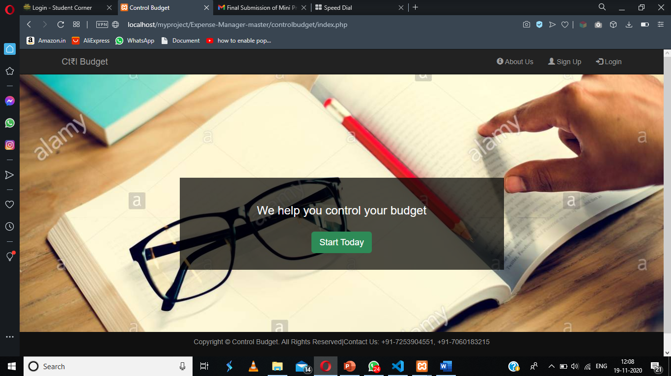

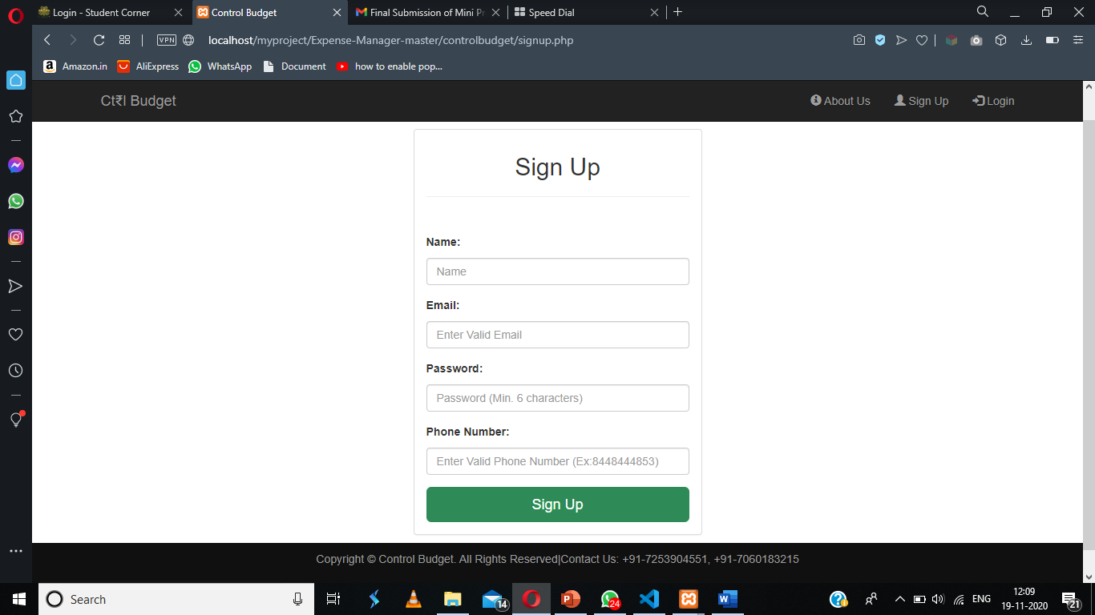

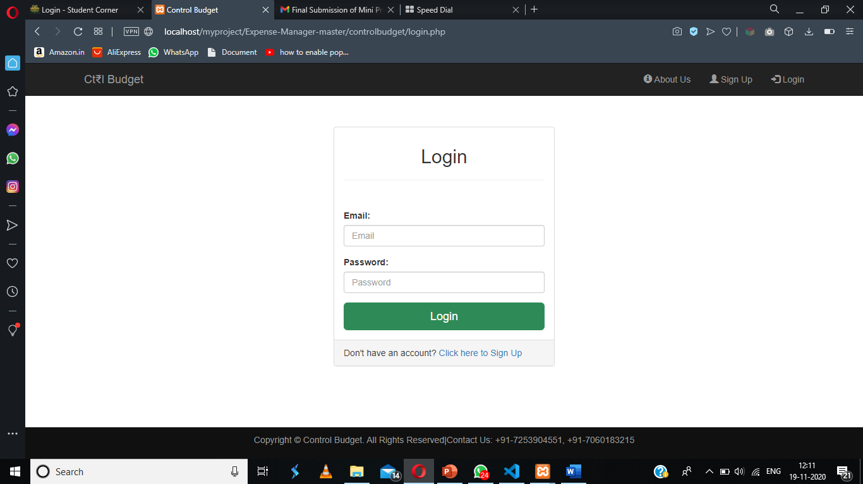

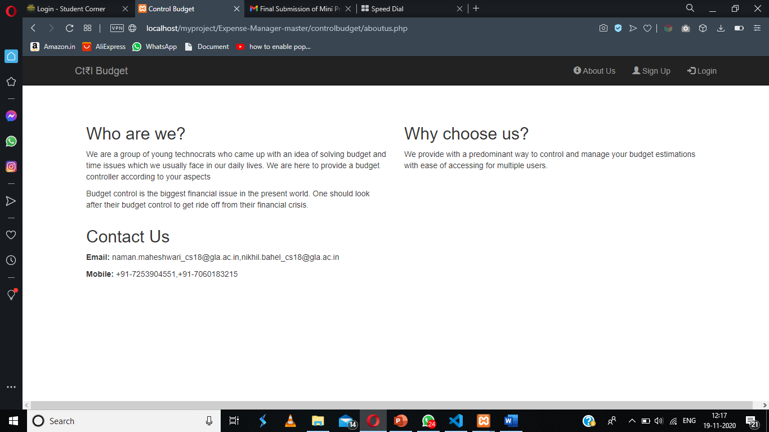

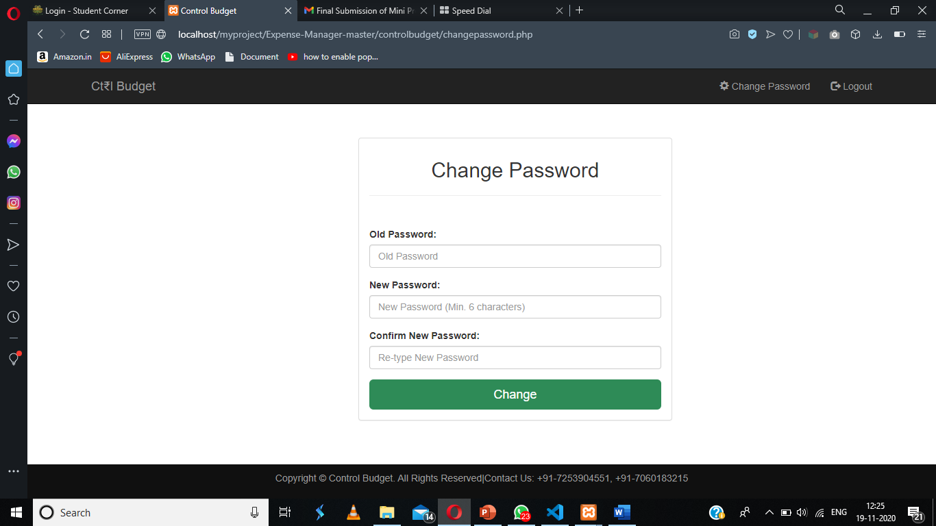

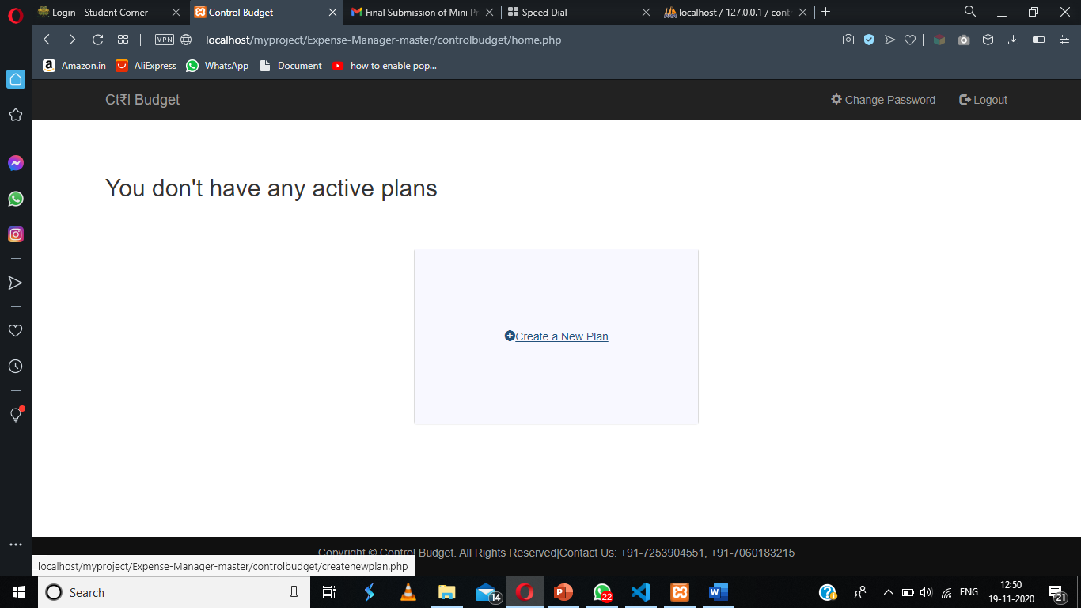

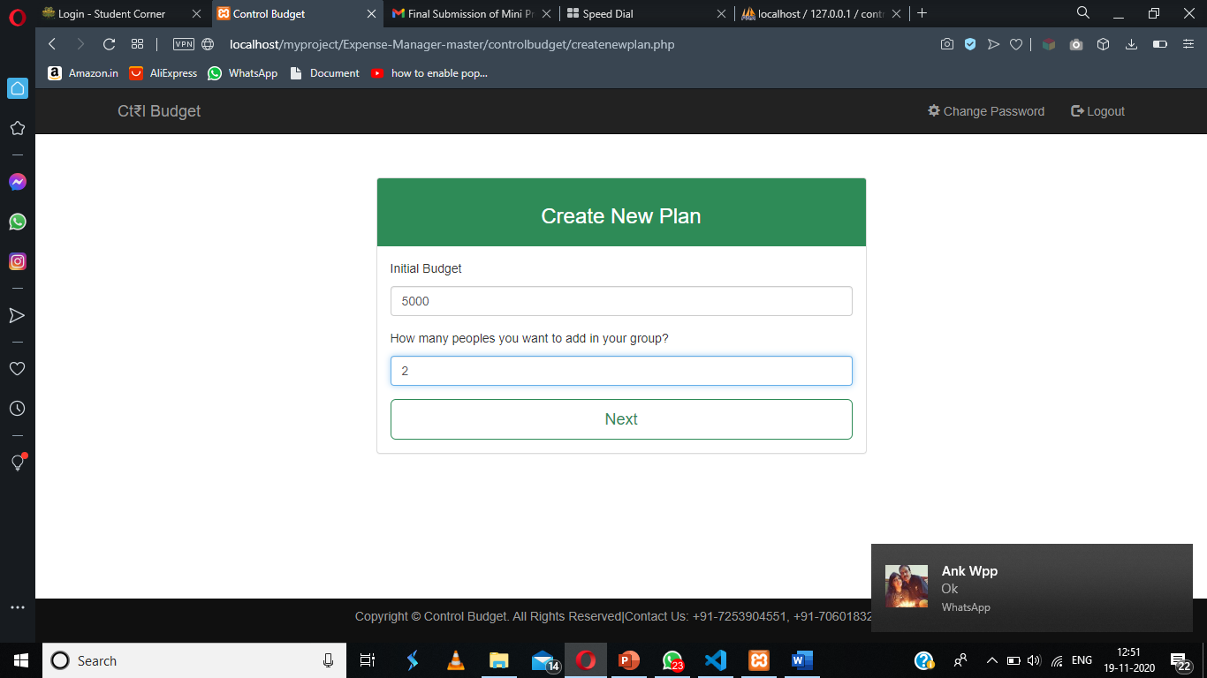

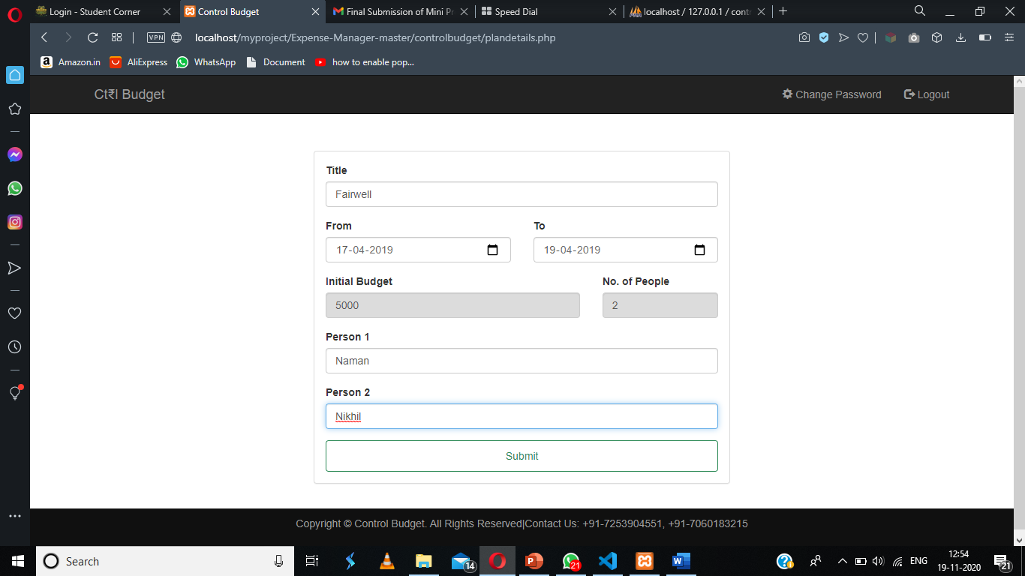

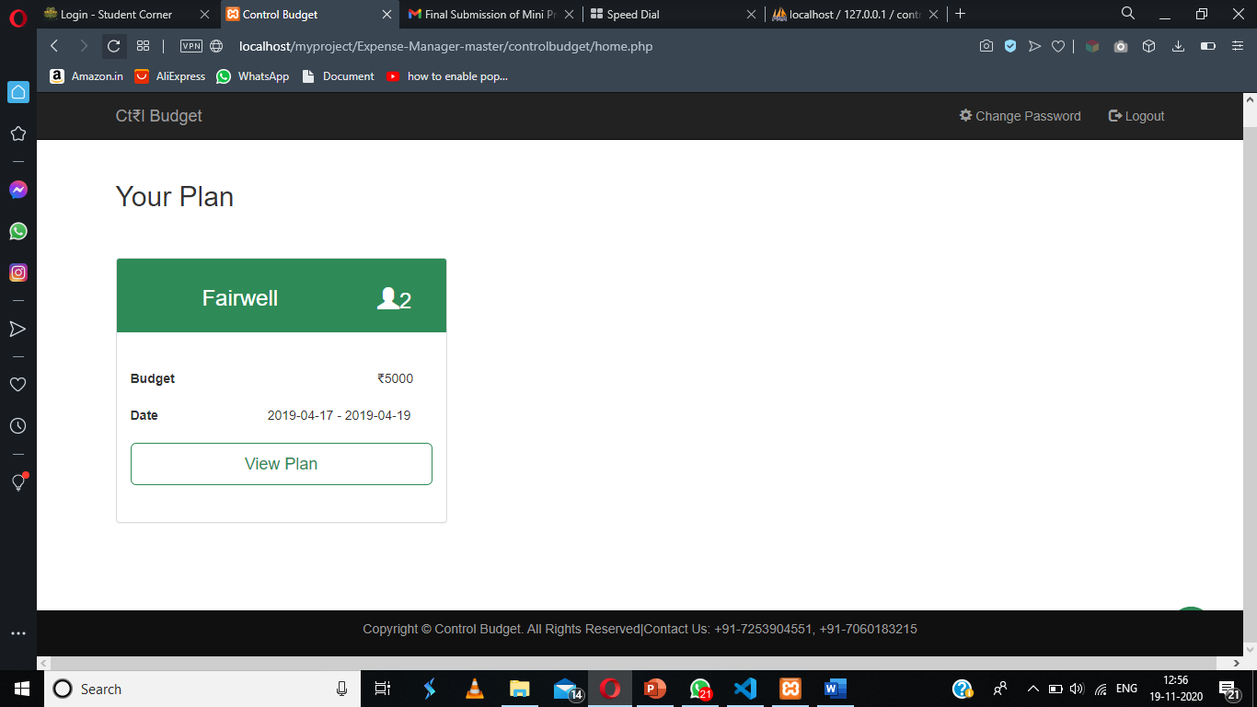

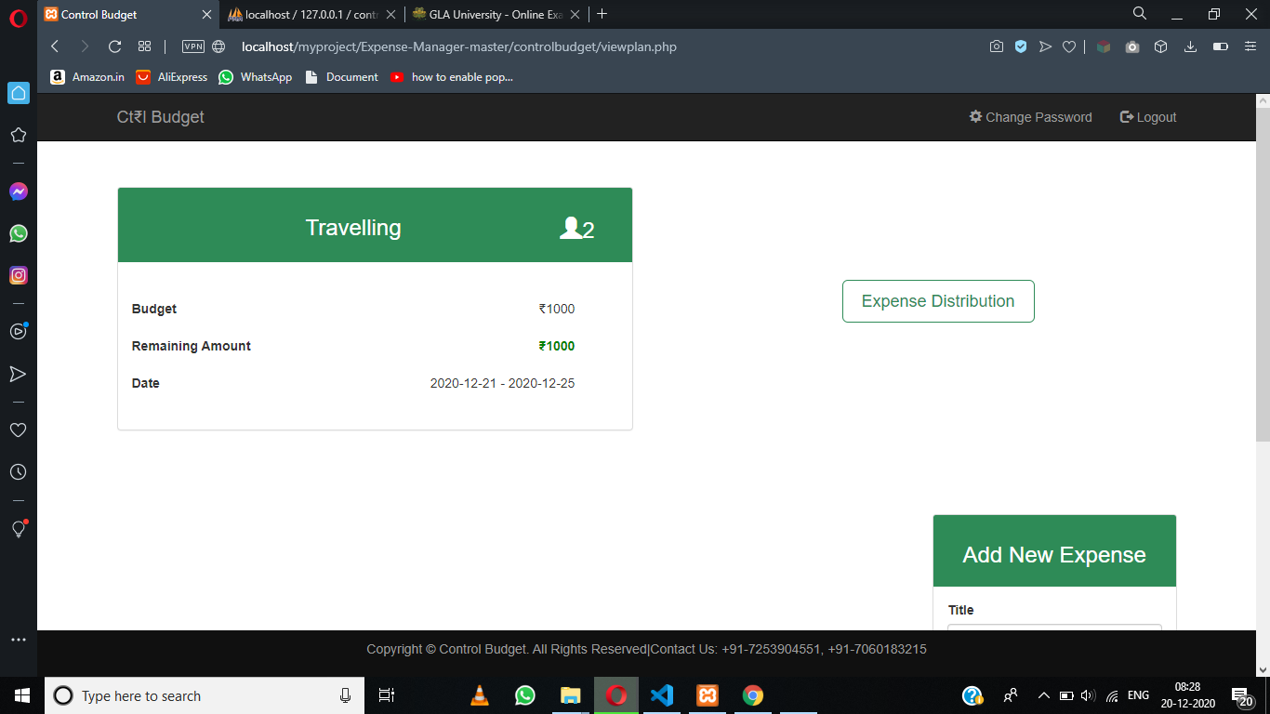

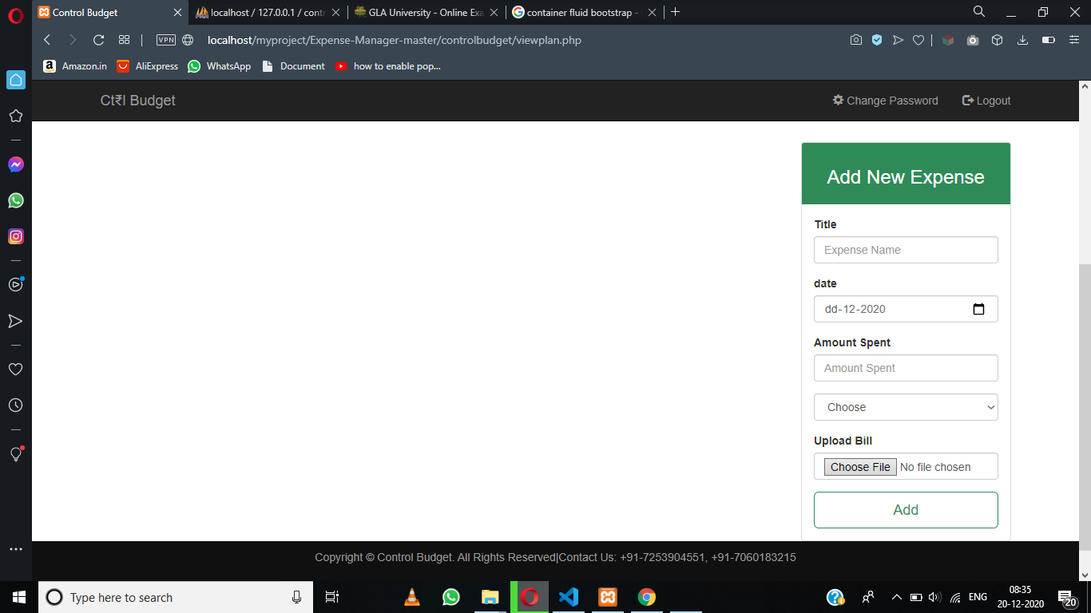

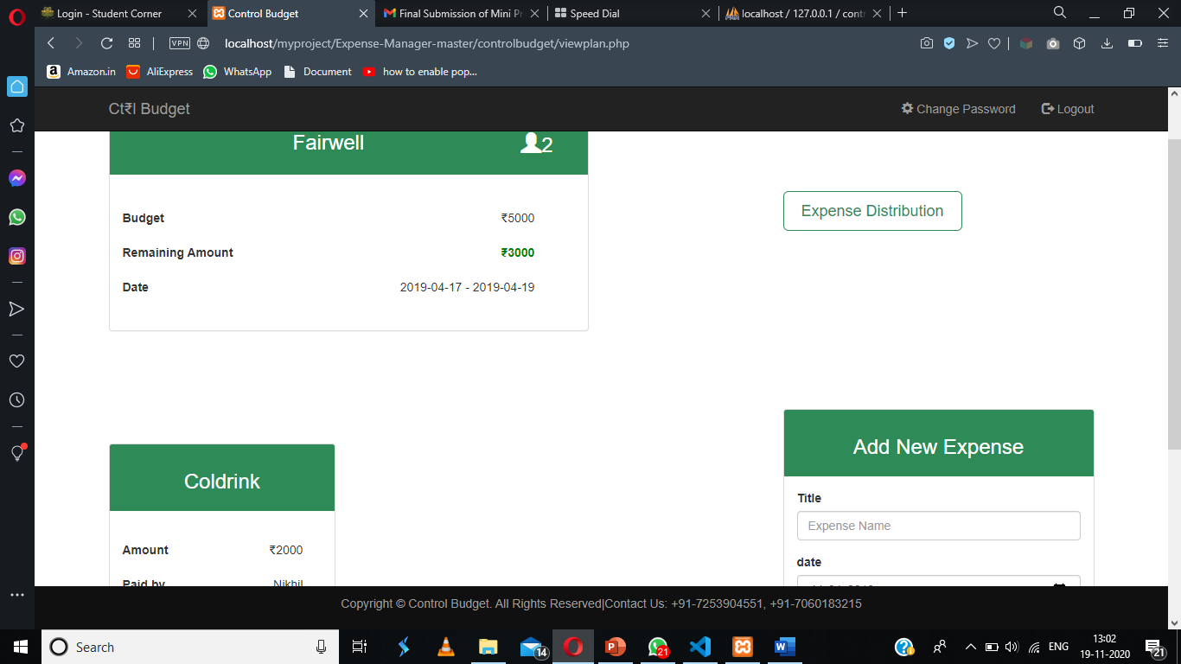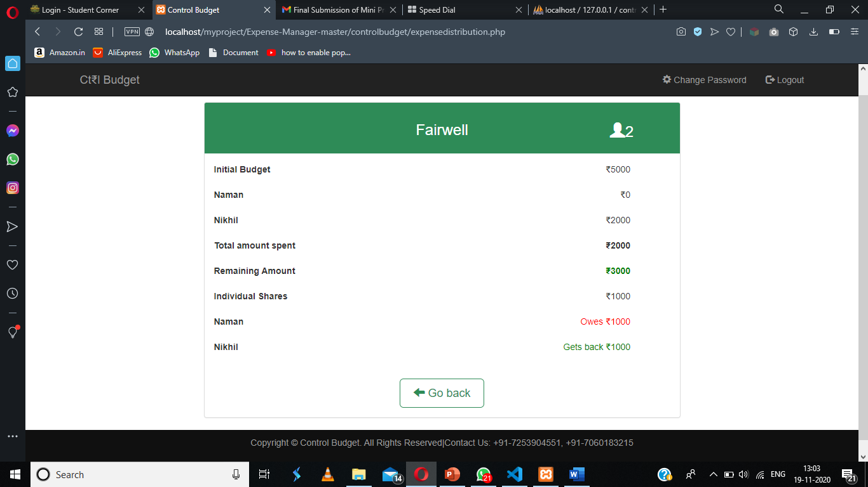

**Testing**

**For testing, we have made an account (sign up) named “Boy” with the following details.**

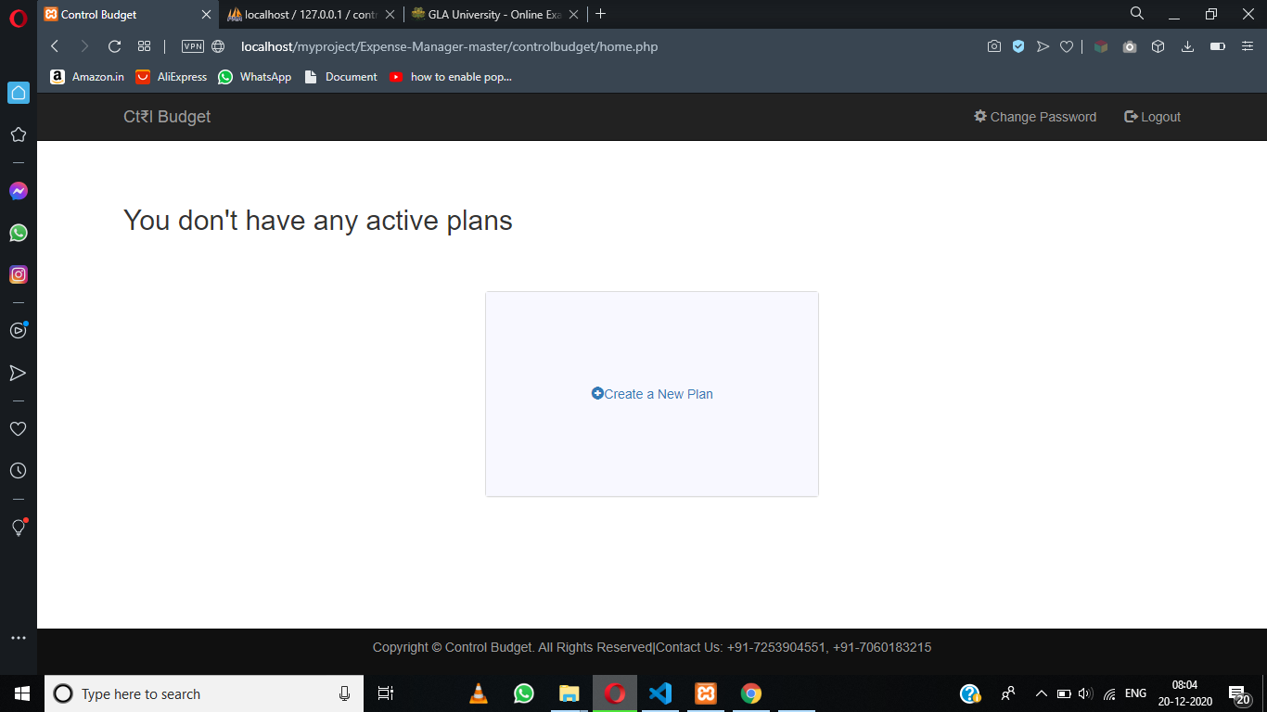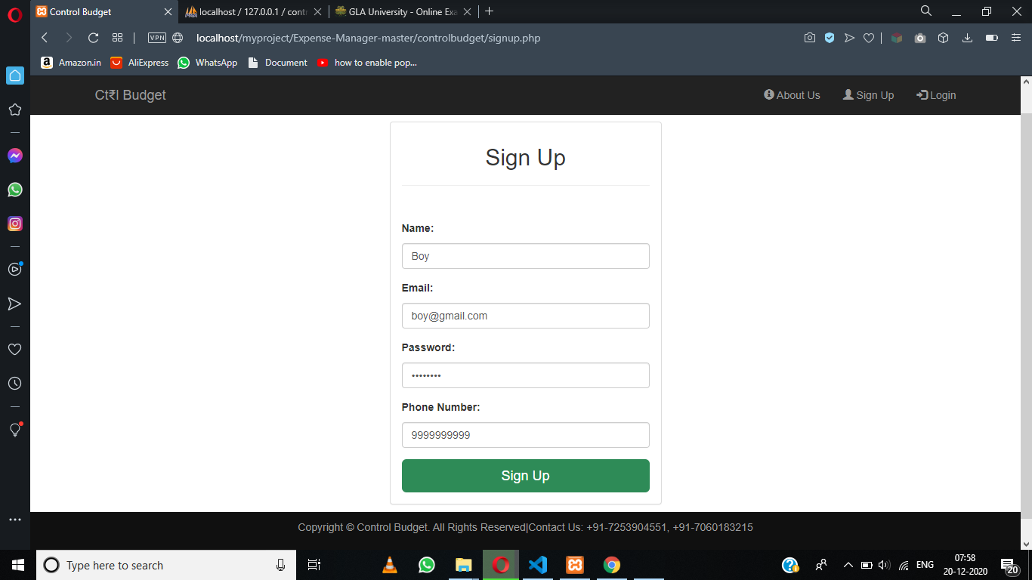

**After creating account, it redirects to Home page, where we have don’t have any plans**

**Now, we have made plan of initial budget of 1000 with two peoples in group.**

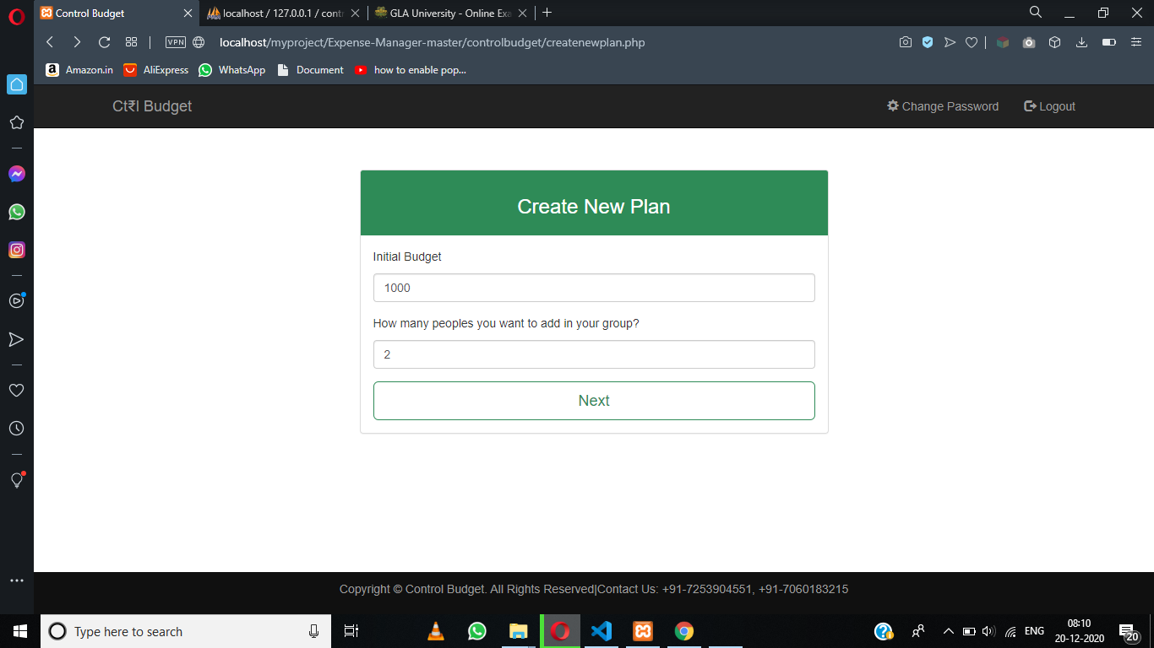

**We have named title as “travelling” dated from 21-12-2020 to 25-12-2020**

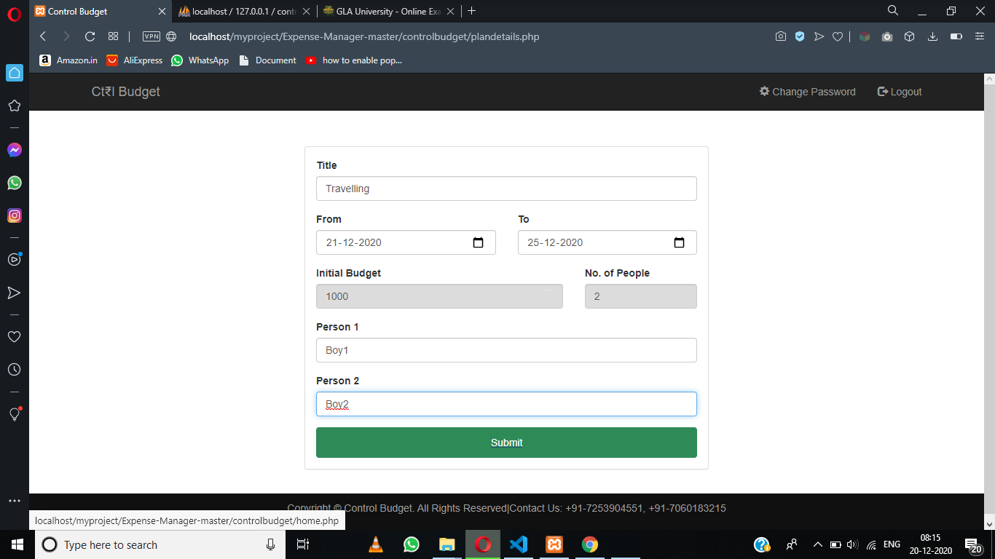

**After making plan, it redirects us to Homepage where we see or plan and view it and and add expense in it, we can add more plan by clicking the “+” sign in the right-bottom**

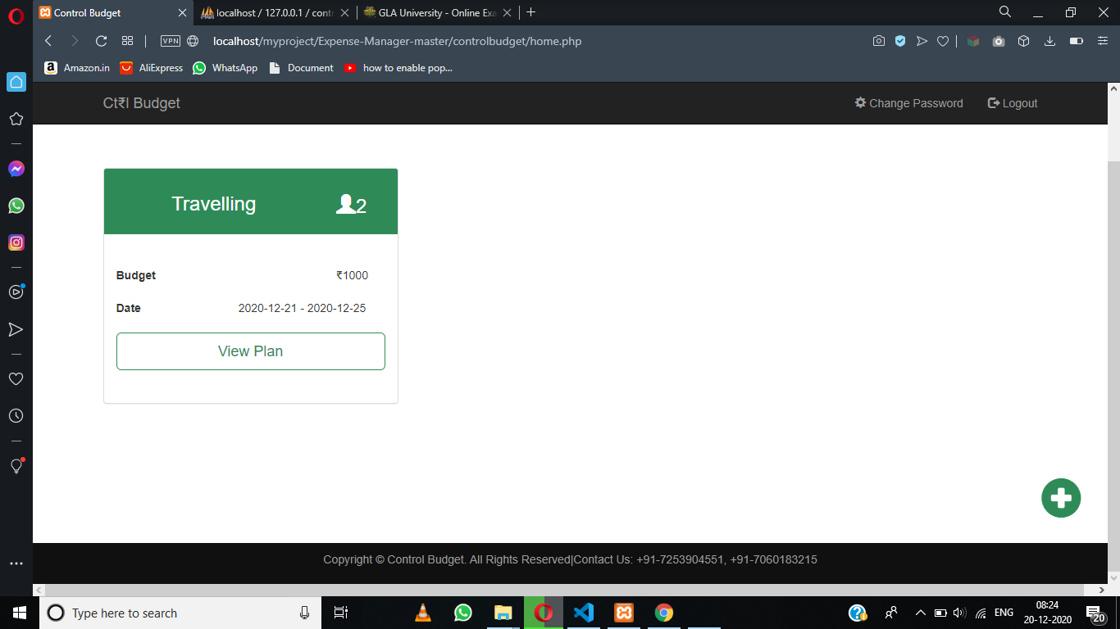

**When we click on view-plan button, it takes us to view-plan page, where it looks like this. In top-most left the top, we see information about our plan. In top-right, there is a expense distribution button and by clicking that we see our expense distribution. In right-bottom, there is a add-expense form, where we can add expense.**

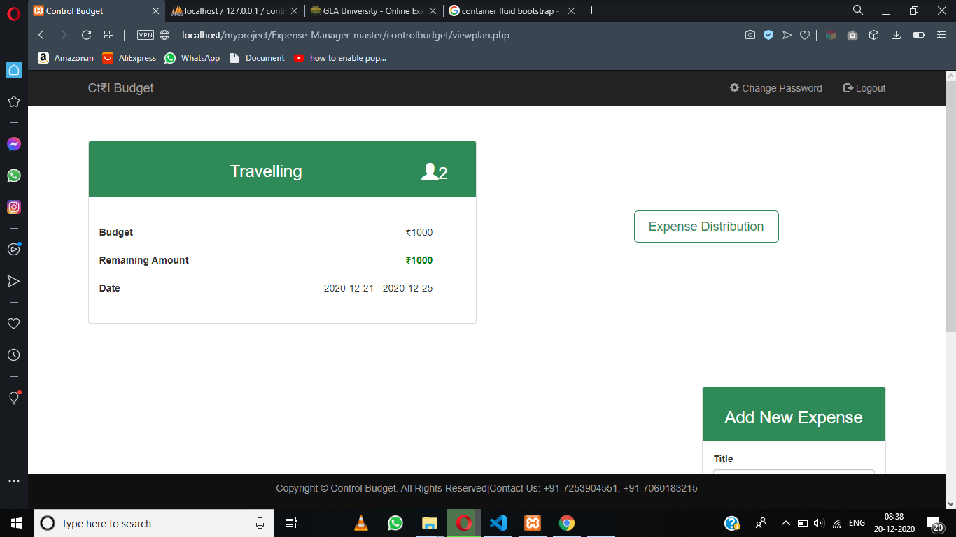



**Now, we add expense of Mathura and Agra, with amount spent 300 and 1000 respectively. Note our budget is only 1000, so there is a overspent now. We can add bill also but only in PNG, JPG format.**

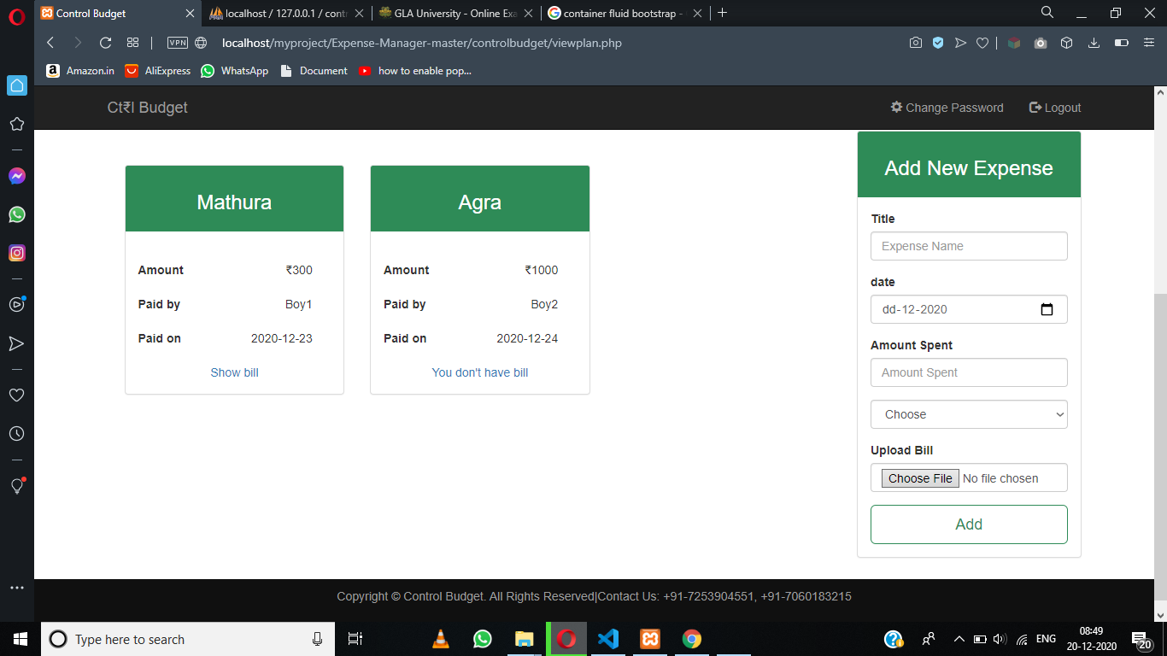

**Now, if we again scroll up and see our plan information, it shows overspent by 300means it show correct information as our initial budget is 1000 and we spent 1300**

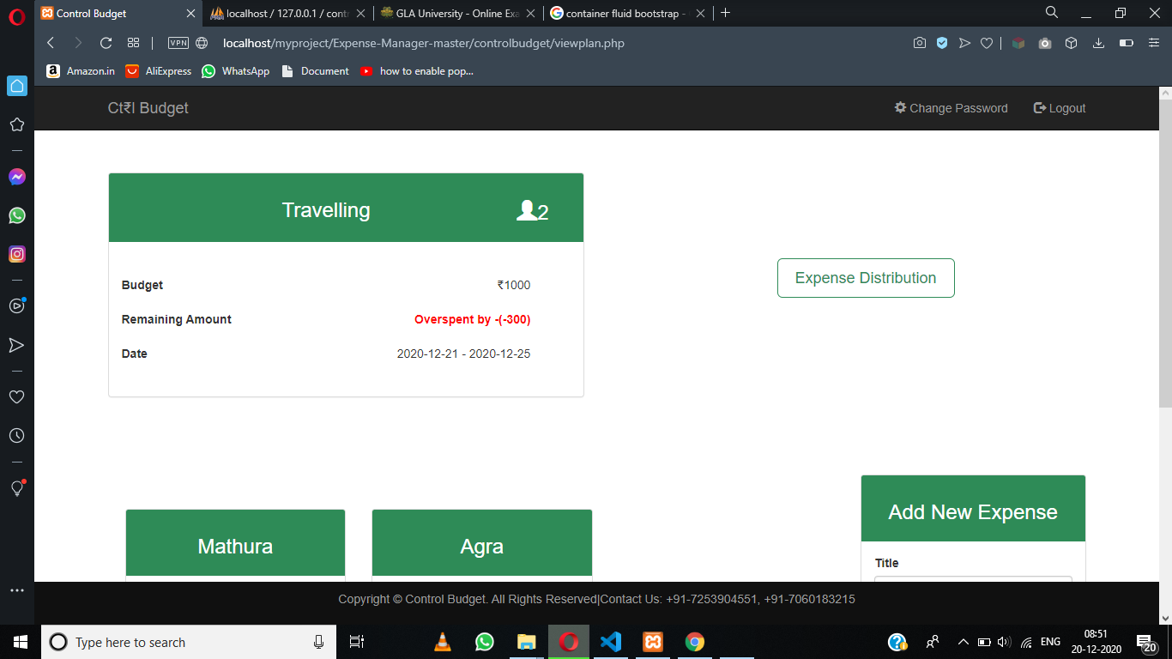

**Now, if we click on ”expense distribution” button ,it looks like this**

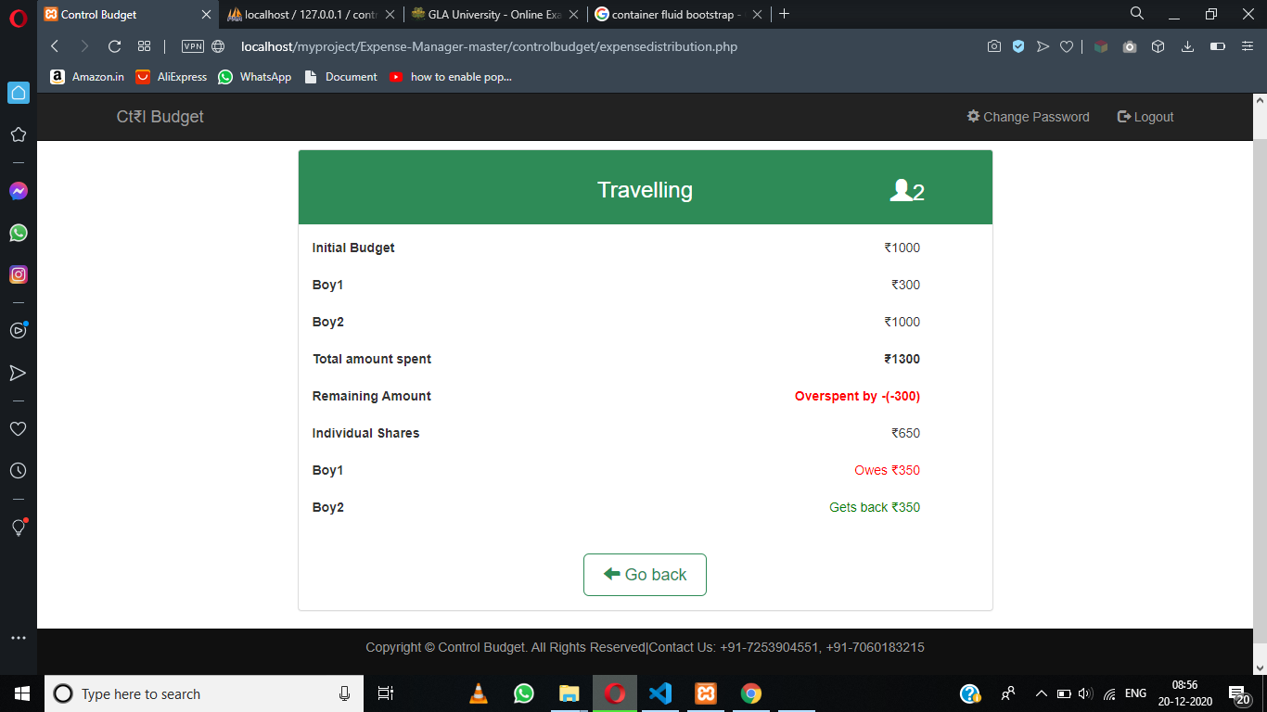

**Implementation**

**CODE**

**Index.php:**

<?php

require 'includes/common.php';

?>

<!DOCTYPE html>

<html>

    <head>

        <title>Control Budget</title>

        <link rel="stylesheet" href="https://maxcdn.bootstrapcdn.com/bootstrap/3.3.7/css/bootstrap.min.css" >

    <script src="https://ajax.googleapis.com/ajax/libs/jquery/1.12.4/jquery.min.js"></script>

    <script src="https://maxcdn.bootstrapcdn.com/bootstrap/3.3.7/js/bootstrap.min.js"></script>

    <link rel="stylesheet" href="css/style.css"  type="text/css">

    </head>

    <body>

        <?php

            require 'includes/header.php';

        ?>

        <div id="banner-image">

            <div class="container">

                <div id="banner-content">

                    <h3>We help you control your budget</h3><br>

                    <a href="login.php" class="btn btn-success btn-lg">Start Today</a>

                </div>

            </div>

        </div>

        <?php

            require 'includes/footer.php';

        ?>

    </body>

</html>

**header.php**

<div class="navbar navbar-inverse navbar-fixed-top">

     <div class="container">

         <div class="navbar-header">

             <button type="button" class="navbar-toggle" data-toggle="collapse" datatarget="#myNavbar">

                 <span class="icon-bar"></span>

                 <span class="icon-bar"></span>

                 <span class="icon-bar"></span>

             </button>

             <a class="navbar-brand" href="index.php">Ct&#8377;l Budget</a>

         </div>

         <div class="collapse navbar-collapse" id="myNavbar">

             <ul class="nav navbar-nav navbar-right">

      <?php

      if (isset($_SESSION['email'])) {

          ?>

                 <li><a href = "changepassword.php"><span class = "glyphicon glyphicon-cog"></span> Change Password</a></li>

                 <li><a href = "logout.php"><span class = "glyphicon glyphicon-log-out"></span> Logout</a></li>

         <?php

      }

       else {  ?>

                 <li><a href = "aboutus.php"><span class = "glyphicon glyphicon-info-sign"></span> About Us</a></li>

                 <li><a href="signup.php"><span class="glyphicon glyphicon-user"></span> Sign Up</a></li>

                 <li><a href="login.php"><span class="glyphicon glyphicon-log-in"></span> Login</a></li>

        <?php

        }

        ?>

             </ul>

         </div>

     </div>

 </div>

**footer.php**

<footer>

     <div class="container">

         <center>

             <p>Copyright &copy; Control Budget. All Rights Reserved|Contact Us: +91-7253904551, +91-7060183215 </p>

         </center>

     </div>

 </footer>

**common.php**

<?php

$con=mysqli_connect("localhost","root","","controlbudget") or die(mysqli_error($con));

if(!isset($_SESSION)){

session_start();}

?>

**Aboutus.php**

<!DOCTYPE html>

<html>

    <head>

        <title>Control Budget</title>

        <link rel="stylesheet" href="https://maxcdn.bootstrapcdn.com/bootstrap/3.3.7/css/bootstrap.min.css" >

    <script src="https://ajax.googleapis.com/ajax/libs/jquery/1.12.4/jquery.min.js"></script>

    <script src="https://maxcdn.bootstrapcdn.com/bootstrap/3.3.7/js/bootstrap.min.js"></script>

    <link rel="stylesheet" href="css/style.css"  type="text/css">

    </head>

    <body>

        <?php

            include 'includes/header.php';

        ?>

        <div class="row">

            <div class=" col-xs-offset-1 col-xs-5">

                <h2>Who are we?</h2>

                <p>We are a group of young technocrats who came up with an idea of solving budget and time issues which we usually face in our daily lives. We are here to provide a budget controller according to your aspects </p>

                <p>Budget control is the biggest financial issue in the present world. One should look after their budget control to get ride off from their financial crisis.</p>

            </div>

            <div class="col-xs-5">

                <h2>Why choose us?</h2>

                <p>We provide with a predominant way to control and manage your budget estimations with ease of accessing for multiple users. </p>

            </div>

        </div>

        <div class="row">

            <div class="col-xs-offset-1 col-xs-5">

                <h2>Contact Us</h2>

                <p><b>Email: </b>naman.maheshwari_cs18@gla.ac.in,nikhil.bahel_cs18@gla.ac.in</p>

                <p><b>Mobile: </b>+91-7253904551,+91-7060183215</p>

            </div>

        </div>

    </body>

</html>

**Signup.php**

<?php

require 'includes/common.php';

if(isset($_SESSION['email'])){

  header('location:home.php');

}

?>

<!DOCTYPE html>

<html>

    <head>

        <title>Control Budget</title>

        <link rel="stylesheet" href="https://maxcdn.bootstrapcdn.com/bootstrap/3.3.7/css/bootstrap.min.css" >

    <script src="https://ajax.googleapis.com/ajax/libs/jquery/1.12.4/jquery.min.js"></script>

    <script src="https://maxcdn.bootstrapcdn.com/bootstrap/3.3.7/js/bootstrap.min.js"></script>

    <link rel="stylesheet" href="css/style.css"  type="text/css">

    </head>

    <body>

    <?php

    include 'includes/header.php';

    ?>

        <div class="container">

            <div class="row">

                <div class="col-xs-offset-4 col-xs-4">

                    <div class="panel">

                        <div class="panel-heading">

                            <center>

                                <h2>Sign Up</h2>

                            </center>

                            <hr>

                        </div>

                        <div class="panel-body">

                            <form method="post" action="signup_script.php">

                                <div class="form-group">

                                    <div class="row">

                                        <p style="font-weight: bold; padding-left: 15px">Name:</p>

                                        <div class="col-xs-12">

                                            <input type="text" class="form-control" placeholder="Name" name="name" required="true" pattern="^[A-Za-z\s]{1,}[\.]{0,1}[A-Za-z\s]{0,}$" >

                                        </div>

                                    </div>

                                </div>

                                <div class="form-group">

                                    <div class="row">

                                        <p style="font-weight: bold; padding-left: 15px">Email:</p>

                                        <div class="col-xs-12">

                                            <input type="text" class="form-control" placeholder="Enter Valid Email" name="email" required="true" pattern="[a-z0-9._%+-]+@[a-z0-9.-]+\.[a-z]{2,3}$">

                                        </div>

                                    </div>

                                </div>

                                <div class="form-group">

                                    <div class="row">

                                        <p style="font-weight: bold; padding-left: 15px">Password:</p>

                                        <div class="col-xs-12">

                                            <input type="password" class="form-control" placeholder="Password (Min. 6 characters)" name="password" required="true" pattern=".{6,}">

                                        </div>

                                    </div>

                                </div>

                                <div class="form-group">

                                    <div class="row">

                                        <p style="font-weight: bold; padding-left: 15px">Phone Number:</p>

                                        <div class="col-xs-12">

                                            <input type="tel" class="form-control" placeholder="Enter Valid Phone Number (Ex:8448444853)" name="contact" pattern="[789][0-9]{9}" >

                                        </div>

                                    </div>

                                </div>

                                <input type="submit" value="Sign Up" class="btn btn-success btn-lg btn-block">

                            </form>

                        </div>

                    </div>

                </div>

            </div>

        </div>

        <?php

    require 'includes/footer.php';

    ?>

    </body>

</html>

**signup_script.php**

<?php

require("includes/common.php");

  // Getting the values from the signup page using $_POST[] and cleaning the data submitted by the user.

  $name = mysqli_real_escape_string($con, $_POST['name']);

  $email = mysqli_real_escape_string($con, $_POST['email']);

  $password = mysqli_real_escape_string($con, $_POST['password']);

  $pass=$password;

  $password = MD5($password);

  $contact = mysqli_real_escape_string($con, $_POST['contact']);

  $regex_email = "/^[_a-z0-9-]+(\.[_a-z0-9-]+)*@[a-z0-9-]+(\.[a-z0-9-]+)*(\.[a-z]{2,3})$/";

  $regex_num = "/^[789][0-9]{9}$/";

  $result = mysqli_query($con, "SELECT * FROM user WHERE email='$email'")or die($mysqli_error($con));

  $num = mysqli_num_rows($result);

  if ($num != 0) {

      echo "<script>alert('Email already exits')</script>";

      echo("<script>location:href='signup.php'</script>");

  } else if (!preg_match($regex_email, $email)) {

      echo "<script>alert('Email entered is invalid')</script>";

      echo "<script>locaion.href='signup.php'</script>";

  } else if (!preg_match($regex_num, $contact)) {

      echo "<script>alert('Contact number is not valid')</script>";

      echo "<script>location.href='signup.php'</script>";

  } else if(strlen($pass)<6){

      echo "<script>alert('Minimum 6 characters required')</script>";

      echo "<script>location.href='signup.php'</script>";

  }else{

    $query = "INSERT INTO user(name, email, password, contact)values('" . $name . "','" . $email . "','" . $password . "','" . $contact . "')";

    mysqli_query($con, $query) or die(mysqli_error($con));

    $user_id = mysqli_insert_id($con);

    $_SESSION['email'] = $email;

    $_SESSION['id'] = $user_id;

    header('location: home.php');

  }

?>

**Login.php**

<?php

require 'includes/common.php';

if(isset($_SESSION['email'])){

  header('location:home.php');

}

?>

<!DOCTYPE html>

<html>

    <head>

        <title>Control Budget</title>

        <link rel="stylesheet" href="https://maxcdn.bootstrapcdn.com/bootstrap/3.3.7/css/bootstrap.min.css" >

    <script src="https://ajax.googleapis.com/ajax/libs/jquery/1.12.4/jquery.min.js"></script>

    <script src="https://maxcdn.bootstrapcdn.com/bootstrap/3.3.7/js/bootstrap.min.js"></script>

    <link rel="stylesheet" href="css/style.css"  type="text/css">

    </head>

    <body style="background: url(../img/login-bg.jpg);">

    <?php

    include 'includes/header.php';

    ?>

        <div class="container">

            <div class="rowlg">

                <div class="col-xs-offset-4 col-xs-4"style="background: url(../img/login-bg.jpg);">

                    <div class="panel">

                        <div class="panel-heading">

                            <center>

                                <h2>Login</h2>

                            </center>

                            <hr>

                        </div>

                        <div class="panel-body">

                            <form method="post" action="login_script.php">

                                <div class="form-group">

                                    <div class="row">

                                        <div class="col-xs-12">

                                            <label for="email">Email:</label>

                                            <input type="text" class="form-control" id="email" placeholder="Email" name="email" >

                                        </div>

                                    </div>

                                </div>

                                <div class="form-group">

                                    <div class="row">

                                        <div class="col-xs-12">

                                            <label for="password">Password:</label>

                                            <input type="password" class="form-control" id="password" placeholder="Password" name="password" >

                                        </div>

                                    </div>

                                </div>

                                <input type="submit" value="Login" class="btn btn-lg btn-block btn-success">

                            </form>

                        </div>

                        <div class="panel-footer">

                            Don't have an account? <a href='signup.php'>Click here to Sign Up</a>

                        </div>

                    </div>

                </div>

            </div>

        </div>

        <?php

    require 'includes/footer.php';

    ?>

    </body>

</html>

**Login_script.php**

<?php

require("includes/common.php");

/** @var type $email */

$email = mysqli_real_escape_string($con, $_POST['email']);

$password = mysqli_real_escape_string($con, $_POST['password']);

$password = MD5($password);

// Query checks if the email and password are present in the database.

//$query = "SELECT id, email FROM users WHERE email='$email' and password='$password'";

$result = mysqli_query($con, "SELECT id,email FROM user WHERE email='$email' and password='$password'")or die($mysqli_error($con));

$num = mysqli_num_rows($result);

// If the email and password are not present in the database, the mysqli_num_rows returns 0, it is assigned to $num.

if ($num == 0) {

  echo "<script>alert('Enter correct email-id and password')</script>";

  echo("<script>location:href='login.php'</script>");

} else {

  $row = mysqli_fetch_array($result);

  $_SESSION['id']=$row['id'];

  $_SESSION['email']=$row['email'];

  header('location: home.php');

}

?>

**Logout.php**

<?php

session_start();

if(!isset($_SESSION['email'])){

    header('location:index.php');

}

session_destroy();

header('location:index.php');

?>

**Home.php**

<?php

require 'includes/common.php';

?>

<!DOCTYPE html>

<html>

    <head>

        <title>Control Budget</title>

        <link rel="stylesheet" href="https://maxcdn.bootstrapcdn.com/bootstrap/3.3.7/css/bootstrap.min.css" >

    <script src="https://ajax.googleapis.com/ajax/libs/jquery/1.12.4/jquery.min.js"></script>

    <script src="https://maxcdn.bootstrapcdn.com/bootstrap/3.3.7/js/bootstrap.min.js"></script>

    <link rel="stylesheet" href="css/style.css"  type="text/css">

    </head>

    <body>

<?php

     require 'includes/header.php';

     ?>

     <?php

     $query= mysqli_query($con,"select * from plandetails where user_id='".$_SESSION['id']."'");

     $num= mysqli_num_rows($query);

     if($num==0){ ?>

        <div class="container">

        <div class="row">

            <div class="col-xs-5">

                <h2>You don't have any active plans</h2>

            </div>

        </div>

            <div class="row">

                <div class="col-xs-offset-4 col-xs-4">

                    <div style="margin-top: 50px;"class="panel">

                        <div class="panel-body panel-primary style">

                            <center>

                                <a href = "createnewplan.php"><span class = "glyphicon glyphicon-plus-sign"></span>Create a New Plan</a>

                            </center>

                        </div>

                    </div>

                </div>

            </div>

        </div>

      <?php }

      else  { ?>

        <div class="container">

            <div class="row">

            <div class="col-xs-4">

                    <h2>Your Plan</h2>

                </div>

            </div>

            <div class="row">

    <?php

    $result="SELECT id FROM plandetails WHERE user_id='".$_SESSION['id']."'";

    $query1= mysqli_query($con,$result);

    while ($row= mysqli_fetch_array($query1)){

    $_SESSION['planidarray']=$row['id'];

    $query= mysqli_query($con,"select * from plandetails where user_id='".$_SESSION['id']."' and id='".$_SESSION['planidarray']."'") or die(mysqli_error($con));

        $row= mysqli_fetch_array($query);

        $_SESSION['people']=$row['people'];

        $_SESSION['title']=$row['title'];

        $_SESSION['initialbudget']=$row['initial_budget'];

        $_SESSION['from']=$row['from_date'];

        $_SESSION['to']=$row['to_date'];

    ?>

                <div class="col-xs-4">

                    <div style="margin-top:40px;"class="panel">

                        <div class="panel-heading panel-style">

                            <div class="row">

                                <div class="col-xs-offset-1 col-xs-7">

                                    <center><h3><?php echo $_SESSION['title'];?></h3></center>

                                </div>

                                <div class="col-xs-offset-1 col-xs-3">

                                    <h3> <span class = "glyphicon glyphicon-user"></span><?php echo $_SESSION['people'];?></h3>

                                </div>

                            </div>

                        </div>

                        <div style="padding-top:40px; padding-bottom: 40px;" class="panel-body">

                            <div class="row">

                                <div class="col-xs-6">

                                    <b>Budget</b>

                                </div>

                                <div class="col-xs-offset-3 col-xs-3">

                                    &#8377;<?php echo $_SESSION['initialbudget'];?>

                                </div>

                            </div><br>

                            <div class="row">

                                <div class="col-xs-3">

                                    <b>Date</b>

                                </div>

                                <div class="col-xs-offset-2 col-xs-7">

                                    <?php echo $_SESSION['from'];?> - <?php echo $_SESSION['to']; ?>

                                </div>

                            </div><br>

                            <?php $_SESSION['planid']=$_SESSION['planidarray']; ?>

                            <a href="viewplan.php?planid=<?php echo $_SESSION['planid'];?>"><input type="submit" value="View Plan" class="btn btn-lg btn-block btn1"></a>

                        </div>

                    </div>

         </div><?php

         }?>

            </div>

        </div>

        <div class="row">

            <div class="col-xs-offset-11 col-xs-1">

                <a href="createnewplan.php"><span class = "glyphicon glyphicon-plus-sign gly"></span></a>

            </div>

        </div>

      <?php }

      ?>

        <?php

    include 'includes/footer.php';?>

    </body>

</html>

**Addnewplan.php**

<?php

require 'includes/common.php';

?>

<!DOCTYPE html>

<html>

    <head>

        <title>Control Budget</title>

        <link rel="stylesheet" href="https://maxcdn.bootstrapcdn.com/bootstrap/3.3.7/css/bootstrap.min.css" >

    <script src="https://ajax.googleapis.com/ajax/libs/jquery/1.12.4/jquery.min.js"></script>

    <script src="https://maxcdn.bootstrapcdn.com/bootstrap/3.3.7/js/bootstrap.min.js"></script>

    <link rel="stylesheet" href="css/style.css"  type="text/css">

    </head>

    <body>

    <?php

    include 'includes/header.php';

    ?>

        <div class="container">

            <div class="row">

                <div class="col-xs-offset-3 col-xs-6">

                    <div class="panel">

                        <div class="panel-heading panel-style">

                            <center>

                                <h3>Create New Plan</h3>

                            </center>

                        </div>

                        <div class="panel-body">

                            <form method="post" action="plandetails.php">

                                 <div class="form-group">

                                    <div class="row">

                                        <p style="padding-left: 15px">Initial Budget</p>

                                        <div class="col-xs-12">

                                            <input type="text" class="form-control" placeholder="Initial Budget (Ex 4000)" name="initialbudget" required="true" >

                                        </div>

                                    </div>

                                </div>

                                 <div class="form-group">

                                    <div class="row">

                                        <p style="padding-left: 15px">How many peoples you want to add in your group?</p>

                                        <div class="col-xs-12">

                                            <input type="text" class="form-control" placeholder="No. of people" name="people" required="true" >

                                        </div>

                                    </div>

                                </div>

                                <input href="plandetails.php" type="submit" value="Next" class="btn btn-lg btn-block btn1">

                            </form>

                        </div>

                    </div>

                </div>

            </div>

        </div>

        <?php

    require 'includes/footer.php';

?>

    </body>

</html>

**Viewplan.php**

<?php

require 'includes/common.php';

?>

<!DOCTYPE html>

<!--

To change this license header, choose License Headers in Project Properties.

To change this template file, choose Tools | Templates

and open the template in the editor.

-->

<html>

    <head>

        <title>Control Budget</title>

        <link rel="stylesheet" href="https://maxcdn.bootstrapcdn.com/bootstrap/3.3.7/css/bootstrap.min.css" >

    <script src="https://ajax.googleapis.com/ajax/libs/jquery/1.12.4/jquery.min.js"></script>

    <script src="https://maxcdn.bootstrapcdn.com/bootstrap/3.3.7/js/bootstrap.min.js"></script>

    <link rel="stylesheet" href="css/style.css"  type="text/css">

    </head>

    <body>

    <?php

    require 'includes/header.php';

    if(isset($_GET['planid'])){

    $_SESSION['planid']=$_GET['planid'];

    $query= mysqli_query($con,"select * from plandetails where user_id='".$_SESSION['id']."' and id='".$_SESSION['planid']."'") or die(mysqli_error($con));

    $row= mysqli_fetch_array($query);

    $_SESSION['people']=$row['people'];

    $_SESSION['title']=$row['title'];

    $_SESSION['initialbudget']=$row['initial_budget'];

    $_SESSION['from']=$row['from_date'];

    $_SESSION['to']=$row['to_date'];

    $result= mysqli_query($con, "select id from person_names where plan_id='".$_SESSION['planid']."'");

    $row=mysqli_fetch_array($result);

    $_SESSION['pid']=$row['id'];

    ?>

        <div  class="container">

            <div class="row">

                <div class="col-xs-6">

                    <div class="panel">

                        <div class="panel-heading panel-style">

                            <div class="row">

                                <div class="col-xs-offset-3 col-xs-5">

                                    <center><h3><?php echo $_SESSION['title'];?></h3></center>

                                </div>

                                <div class="col-xs-offset-2 col-xs-2">

                                    <h3> <span class = "glyphicon glyphicon-user"></span><?php echo $_SESSION['people'];?></h3>

                                </div>

                            </div>

                        </div>

                        <div style="padding-top:40px; padding-bottom:40px;" class="panel-body">

                            <div class="row">

                                <div class="col-xs-4">

                                    <b>Budget</b>

                                </div>

                                <div class="col-xs-offset-3 col-xs-4 align">

                                    &#8377;<?php echo $_SESSION['initialbudget'];?>

                                </div>

                            </div><br>

                            <div class="row">

                                <div class="col-xs-4">

                                    <b>Remaining Amount</b>

                                </div>

                                <div class="col-xs-offset-3 col-xs-4 align">

                                    <?php

                                    $query= mysqli_query($con, "select sum(amount) as sum from addexpense where planid='".$_SESSION['planid']."'") or die(mysqli_error($con));

                                    $row= mysqli_fetch_array($query);

                                    $_SESSION['totalamount']=$row['sum'];

                                    $Remainingamount= $_SESSION['initialbudget']-$_SESSION['totalamount'];

                                    if($Remainingamount>0){

                                        ?> <div class="cgreen"><b>

                                            <?php

                                            echo "&#8377;$Remainingamount"; ?> </b></div> <?php

                                    } else if($Remainingamount<0){

                                        ?><div class="cred"><b> <?php

                                        echo "Overspent by -($Remainingamount)"; ?> </b></div> <?php

                                    }

                                    ?>

                                </div>

                            </div><br>

                            <div class="row">

                                <div class="col-xs-4">

                                    <b>Date</b>

                                </div>

                                <div class="col-xs-offset-2 col-xs-5 align">

                                    <?php echo $_SESSION['from'];?> - <?php echo $_SESSION['to']; ?>

                                </div>

                            </div>

                        </div>

                    </div>

                </div>

                <div style="margin-top: 100px;" class="col-xs-offset-2 col-xs-4">

                    <a href="expensedistribution.php?planid=<?php echo $_SESSION['planid'];?>"> <input type="submit" value="Expense Distribution" class="btn btn-lg btn1"></a>

                </div>

            </div>

            <div class="row">

                <div class="col-xs-offset-8 col-xs-4">

                    <div class="panel">

                        <div class="panel-heading panel-style">

                            <center>

                                <h3>Add New Expense</h3>

                            </center>

                        </div>

                        <div class="panel-body">

                            <form method="post" action="addexpense.php" enctype="multipart/form-data">

                                <div class="form-group">

                                    <div class="row">

                                        <div class="col-xs-12">

                                            <label for="title">Title</label>

                                            <input type="text" class="form-control" id="title" placeholder="Expense Name" name="title" required="true" >

                                        </div>

                                    </div>

                                </div>

                                <div class="form-group">

                                    <div class="row">

                                        <div class="col-xs-12">

                                            <label for="date">date</label>

                                            <input type="date" class="form-control sample_class" id="date" name="date"min="<?php echo $_SESSION['from']; ?>" max="<?php echo $_SESSION['to']; ?>" required="true" >

                                            <span class="validity"></span>

                                        </div>

                                    </div>

                                </div>

                                <div class="form-group">

                                    <div class="row">

                                        <div class="col-xs-12">

                                            <label for="amtspent">Amount Spent</label>

                                            <input type="text" class="form-control" id="amtspent" placeholder="Amount Spent" name="amountspent" required="true" >

                                        </div>

                                    </div>

                                </div>

                                <div class="form-group">

                                    <div class="row">

                                        <div class="col-xs-12">

                                            <select name="pname" class="form-control">

                                                     <option value="choose">Choose</option>

                                                     <?php for($i=0,$j=$_SESSION['pid'];$i<$_SESSION['people'];$i++){

                                                       $query1= mysqli_query($con,"select person from person_names where plan_id='".$_SESSION['planid']."' and id='$j'");

                                                       $row1= mysqli_fetch_array($query1);

                                                       $_SESSION['person']=$row1['person'];

                                                       $j=$j+1; ?>

                                                     <option value="<?php echo $_SESSION['person']; ?>"><?php echo $_SESSION['person']; }?></option>

                                             </select>

                                        </div>

                                    </div>

                                </div>

                                <div class="form-group">

                                    <div class="row">

                                        <div class="col-xs-12">

                                            <label for="upload">Upload Bill</label>

                                            <input type="file" name="file" class="form-control">

                                        </div>

                                    </div>

                                </div>

                                <a href="addexpense.php?planid=<?php echo $_SESSION['planid'];?>"><input type="submit" value="Add" name='submit'class="btn btn-lg btn-block btn1"></a>

                            </form>

                        </div>

                    </div>

                </div>

            </div>

            <div class="row">

            <?php

            for($i=0,$j=$_SESSION['pid'];$i<$_SESSION['people'];$i++){

            $query= mysqli_query($con, "select * from addexpense where planid='".$_SESSION['planid']."' and pid='$j'") or die(mysqli_error($con));

            $row= mysqli_fetch_array($query);

            $_SESSION['expensename']=$row['title'];

            $_SESSION['amount']=$row['amount'];

            $_SESSION['pname']=$row['person'];

            $_SESSION['pdate']=$row['date'];

            $_SESSION['bill']=$row['bill'];

            if(isset($_SESSION['expensename'])){ ?>

                <div class="col-xs-3">

                    <div style="margin-top: -550px; "class="panel">

                        <div class="panel-heading panel-style">

                            <center>

                                <h3><?php echo $_SESSION['expensename']; ?></h3>

                            </center>

                        </div><br>

                        <div class="panel-body">

                            <div class="row">

                                <div class="col-xs-4">

                                    <b>Amount</b>

                                </div>

                                <div class="col-xs-offset-3 col-xs-4 align">

                                    <?php echo "&#8377;".$_SESSION['amount']; ?>

                                </div>

                            </div><br>

                            <div class="row">

                                <div class="col-xs-4">

                                    <b>Paid by</b>

                                </div>

                                <div class="col-xs-offset-3 col-xs-4 align">

                                    <?php echo $_SESSION['pname']; ?>

                                </div>

                            </div><br>

                            <div class="row">

                                <div class="col-xs-4">

                                    <b>Paid on</b>

                                </div>

                                <div class="col-xs-offset-2 col-xs-5 align">

                                    <?php echo $_SESSION['pdate']; ?>

                                </div>

                            </div><br>

                            <?php

                            if($_SESSION['bill']==null){ ?>

                            <div class="row">

                                <div class="col-xs-12">

                                    <center>

                                        <a href="">You don't have bill</a>

                                    </center>

                                </div>

                            </div>

                           <?php  } else { ?>

                            <div class="row">

                                <div class="col-xs-12">

                                    <center>

                                        <a href="showbill.php?planid=<?php echo $_SESSION['planid'];?>">Show bill</a>

                                    </center>

                                </div>

                            </div>

                          <?php } ?>

                        </div>

                    </div>

                </div>

        <?php  }

            $j=$j+1;

            } ?>

           </div>

        </div>

        <?php

        require 'includes/footer.php';

      } ?>

    </body>

</html>

**Plandetails.php**

<?php

require 'includes/common.php';

$initialbudget= mysqli_real_escape_string($con, $_POST['initialbudget']);

$people= mysqli_real_escape_string($con, $_POST['people']);

?>

<!DOCTYPE html>

<!--

To change this license header, choose License Headers in Project Properties.

To change this template file, choose Tools | Templates

and open the template in the editor.

-->

<html>

    <head>

        <title>Control Budget</title>

        <link rel="stylesheet" href="https://maxcdn.bootstrapcdn.com/bootstrap/3.3.7/css/bootstrap.min.css" >

    <script src="https://ajax.googleapis.com/ajax/libs/jquery/1.12.4/jquery.min.js"></script>

    <script src="https://maxcdn.bootstrapcdn.com/bootstrap/3.3.7/js/bootstrap.min.js"></script>

    <link rel="stylesheet" href="css/style.css"  type="text/css">

    </head>

    <body>

        <?php

        require 'includes/header.php';

        ?>

        <div class="container">

            <div class="row">

                <div class="col-xs-offset-3 col-xs-6">

                    <div class="panel">

                        <div class="panel-body">

                            <form method="post" action="plandetails_script.php">

                                <div class="form-group">

                                    <div class="row">

                                        <div class="col-xs-12">

                                            <label for="title">Title</label>

                                            <input type="text" class="form-control" id="title" placeholder="Enter Title (Ex Trip to Goa)" name="title" required="true" >

                                        </div>

                                    </div>

                                </div>

                                <div class="form-group">

                                    <div class="row">

                                        <div class="col-xs-6">

                                            <label for="from">From</label>

                                            <input type="date" class="form-control sample_class" id="from" name="from" min="2019-04-01" max="2019-04-20" required="true">

                                        </div>

                                        <div class="col-xs-6">

                                            <label for="to">To</label>

                                            <input type="date" class="form-control sample_class" id="to" name="to" min="2019-04-01" max="2019-04-20"required="true" >

                                        </div>

                                    </div>

                                </div>

                                <div class="form-group">

                                    <div class="row">

                                        <div class="col-xs-8">

                                            <label for="initialbudget">Initial Budget</label>

                                            <input type="number" class="form-control st" id="initialbudget" name="initialbudget" value="<?php echo $initialbudget;?>">

                                        </div>

                                        <div class="col-xs-4">

                                            <label for="people">No. of People</label>

                                            <input type="number" class="form-control st" id="people" name="people" value="<?php echo $people;?>" >

                                        </div>

                                    </div>

                                </div>

                               <?php for ($i=1;$i<$people+1;$i++){?>

                                <div class="form-group">

                                    <div class="row">

                                        <div class="col-xs-12">

                                            <label for="person">Person <?php echo $i;?></label>

                                            <input type="text" class="form-control" id="person" name="person<?php echo $i;?>" placeholder="Person <?php echo $i;?> Name" required="true">

                                        </div>

                                    </div>

                                </div>

                               <?php }?>

                                <a href="home.php"><input type="submit" value="Submit" class="btn btn-block btn1"></a>

                            </form>

                        </div>

                    </div>

                </div>

            </div>

        </div>

        <?php

            require 'includes/footer.php';

            ?>

    </body>

</html>

Plandetails_script.php

<?php

require 'includes/common.php';

$title= mysqli_real_escape_string($con, $_POST['title']);

$from= mysqli_real_escape_string($con, $_POST['from']);

$to= mysqli_real_escape_string($con, $_POST['to']);

$initialbudget= mysqli_real_escape_string($con, $_POST['initialbudget']);

$people= mysqli_real_escape_string($con, $_POST['people']);

$query="INSERT into plandetails(title,from_date,to_date,initial_budget,people,user_id) VALUES ('".$title."','".$from."','".$to."','".$initialbudget."','".$people."','".$_SESSION['id']."')";

mysqli_query($con, $query) or die(mysqli_error($con));

$result= mysqli_query($con, "select id from plandetails where initial_budget='$initialbudget' and title='$title'") or die(mysqli_error($con));

$row= mysqli_fetch_array($result);

$_SESSION['planid']=$row['id'];

for($i=1;$i<$people+1;$i++){

    $query=mysqli_query($con,"INSERT into person_names(plan_id,person) VALUES ('".$_SESSION['planid']."','".$_POST["person$i"]."')") or die(mysqli_error($con));

}

header('location:home.php');

?>

Expensedistribution.php

<?php

require 'includes/common.php';

?>

<!DOCTYPE html>

<!--

To change this license header, choose License Headers in Project Properties.

To change this template file, choose Tools | Templates

and open the template in the editor.

-->

<html>

    <head>

        <title>Control Budget</title>

        <link rel="stylesheet" href="https://maxcdn.bootstrapcdn.com/bootstrap/3.3.7/css/bootstrap.min.css" >

    <script src="https://ajax.googleapis.com/ajax/libs/jquery/1.12.4/jquery.min.js"></script>

    <script src="https://maxcdn.bootstrapcdn.com/bootstrap/3.3.7/js/bootstrap.min.js"></script>

    <link rel="stylesheet" href="css/style.css"  type="text/css">

    </head>

    <body>

     <?php

     require 'includes/header.php';

     ?>

        <div class="container">

            <div class="row">

                <div class="col-xs-offset-2 col-xs-8">

                    <div class="panel">

                        <div class="panel-heading panel-style">

                        <div class="row">

                                <div class="col-xs-offset-4 col-xs-4">

                                    <center>

                                         <h3><?php echo $_SESSION['title'];?></h3>

                                    </center>

                                </div>

                                <div class="col-xs-offset-2 col-xs-2">

                                    <h3> <span class = "glyphicon glyphicon-user"></span><?php echo $_SESSION['people'];?></h3>

                                </div>

                            </div>

                        </div>

                        <div class="panel-body">

                            <div class="row">

                                <div class="col-xs-4">

                                    <b>Initial Budget</b>

                                </div>

                                <div class="col-xs-offset-3 col-xs-4 align">

                                    &#8377;<?php echo $_SESSION['initialbudget'];?>

                                </div>

                            </div><br>

                            <?php for($i=0,$j=$_SESSION['pid'];$i<$_SESSION['people'];$i++){

                                $query1= mysqli_query($con,"select person from person_names where plan_id='".$_SESSION['planid']."' and id='$j'");

                                $row1= mysqli_fetch_array($query1);

                                $person=$row1['person'];

                                 ?>

                              <div class="row">

                                <div class="col-xs-4">

                                    <b><?php echo $person;?></b>

                                </div>

                                <div class="col-xs-offset-3 col-xs-4 align">

                                    <?php $query= mysqli_query($con, "select sum(amount) as sum from addexpense where pid='$j'") or die(mysqli_error($con));

                                    $num= mysqli_num_rows($query);

                                    $row= mysqli_fetch_array($query);

                                    if($row['sum']>0){

                                    $amount=$row['sum'];

                                    echo '&#8377;'.$amount; }

                                    else {

                                        echo '&#8377;0';

                                    }

                                    $j=$j+1; ?>

                                </div>

                              </div><br>

                            <?php } ?>

                            <div class="row">

                                <div class="col-xs-4">

                                    <b>Total amount spent</b>

                                </div>

                                <div class="col-xs-offset-3 col-xs-4 align">

                                    <?php $query= mysqli_query($con, "select sum(amount) as sum from addexpense where planid='".$_SESSION['planid']."'") or die(mysqli_error($con));

                                    $row= mysqli_fetch_array($query);

                                    if($row['sum']>0){

                                    $_SESSION['totalamount']=$row['sum'];

                                    ?><b><?php echo '&#8377;'.$_SESSION['totalamount'];?></b> <b> <?php }

                                    else {

                                        echo '&#8377;0'; }

                                    ?></b>

                                </div>

                            </div><br>

                            <div class="row">

                                <div class="col-xs-4">

                                    <b>Remaining Amount</b>

                                </div>

                                <div class="col-xs-offset-3 col-xs-4 align">

                                    <?php

                                    $query= mysqli_query($con, "select sum(amount) as sum from addexpense where planid='".$_SESSION['planid']."'") or die(mysqli_error($con));

                                    $row= mysqli_fetch_array($query);

                                    $_SESSION['totalamount']=$row['sum'];

                                    $Remainingamount= $_SESSION['initialbudget']-$_SESSION['totalamount'];

                                    if($Remainingamount>0){

                                        ?> <div class="cgreen"><b>

                                            <?php

                                            echo "&#8377;$Remainingamount"; ?> </b></div> <?php

                                    } else if($Remainingamount<0){

                                        ?><div class="cred"><b> <?php

                                        echo "Overspent by -($Remainingamount)"; ?> </b></div> <?php

                                    }

                                      ?>

                                </div>

                            </div><br>

                            <div class="row">

                                <div class="col-xs-4">

                                    <b>Individual Shares</b>

                                </div>

                                <div class="col-xs-offset-3 col-xs-4 align">

                                    &#8377;<?php $individualshare=$_SESSION['totalamount']/$_SESSION['people'];

                                    if($individualshare>0){

                                    echo $individualshare; }

                                    else{

                                        echo "0";

                                        echo "<script>alert('All settled up')</script>";

                                        echo("<script>location:href='expensedistributon.php'</script>");

                                    }?>

                                </div>

                            </div><br>

                            <?php for($i=0,$j=$_SESSION['pid'];$i<$_SESSION['people'];$i++){

                                $query1= mysqli_query($con,"select person from person_names where plan_id='".$_SESSION['planid']."' and id='$j'");

                                $row1= mysqli_fetch_array($query1);

                                $person=$row1['person'];

                                 ?>

                              <div class="row">

                                <div class="col-xs-4">

                                    <b><?php echo $person;?></b>

                                </div>

                                <div class="col-xs-offset-3 col-xs-4 align">

                                <?php $query= mysqli_query($con, "select sum(amount) as sumamount from addexpense where pid=$j") or die(mysqli_error($con));

                                    $num= mysqli_num_rows($query);

                                    if($num!=0){

                                    $row= mysqli_fetch_array($query);

                                    $amount=$row['sumamount'];

                                    $personshare=$amount-$individualshare;

                                    if($personshare>0){

                                        ?> <div class="cgreen"> <?php

                                        echo "Gets back &#8377;".$personshare; ?></div> <?php

                                    }else if($personshare<0){

                                        ?> <div class="cred"> <?php

                                        echo "Owes &#8377;".-$personshare; ?></div> <?php

                                    }

                                    else{

                                        echo "&#8377;0";

                                    }

                                    }

                                    $j=$j+1;

                                    ?>

                                </div>

                              </div><br>

                            <?php } ?><br>

                              <center>

                                  <a href="viewplan.php?planid=<?php echo $_SESSION['planid'];?>"> <button type="button" class="btn btn-lg btn1"><span class = "glyphicon glyphicon-arrow-left"></span> Go back</button></a>

                              </center>

                        </div>

                    </div>

                </div>

            </div>

        </div>

        <?php

        require 'includes/footer.php'; ?>

   </body>

</html>

**Database**

Controlbudget.sql

CREATE DATABASE controlbudget;

CREATE TABLE controlbudget.user(

    id INT(11) PRIMARY KEY AUTO_INCREMENT,

    name VARCHAR(225) NOT NULL,

    email VARCHAR(225) NOT NULL,

    password VARCHAR(225) NOT NULL,

    contact BIGINT(11) NOT NULL);

CREATE TABLE controlbudget.plandetails(

    id INT(11) PRIMARY KEY AUTO_INCREMENT,

    user_id INT(11) NOT NULL,

    title VARCHAR(225) NOT NULL,

    from_date DATE NOT NULL,

    to_date DATE NOT NULL,

    initial_budget INT(11) NOT NULL,

    people INT(11) NOT NULL,

    FOREIGN KEY(user_id) REFERENCES user(id) ON UPDATE CASCADE);

CREATE TABLE controlbudget.person_names(

    id INT(11) PRIMARY KEY AUTO_INCREMENT,

    plan_id INT(11) NOT NULL,

    person VARCHAR(225) NOT NULL,

    FOREIGN KEY(plan_id) REFERENCES plandetails(id) ON UPDATE CASCADE);

CREATE TABLE controlbudget.addexpense(

    id INT(11) PRIMARY KEY AUTO_INCREMENT,

    planid INT(11) NOT NULL,

    pid INT(11) NOT NULL,

    title VARCHAR(225) NOT NULL,

    date DATE NOT NULL,

    amount INT(11) NOT NULL,

    person VARCHAR(225) NOT NULL,

    bill VARCHAR(225),

    FOREIGN KEY(planid) REFERENCES plandetails(id) ON UPDATE CASCADE,

    FOREIGN KEY(pid) REFERENCES person_names(id) ON UPDATE CASCADE);

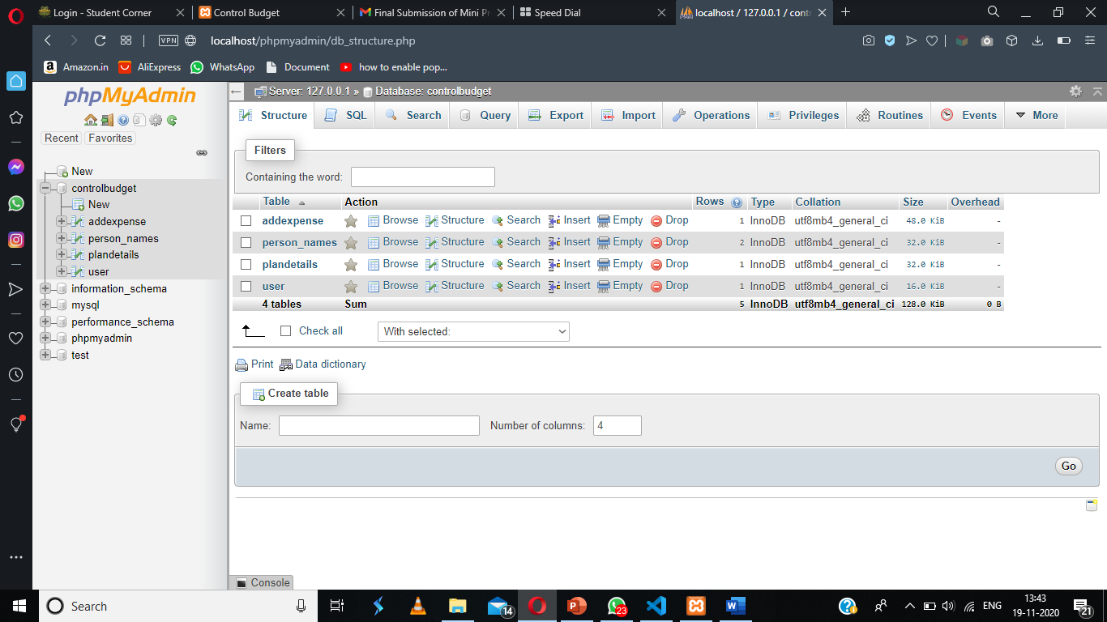

**References**

* www.google,com
* www.youtube.com
* W3School
* Video notes from Internshala